INTRODUCTION
Introduction
The interactive e-commerce system was to be developed for a company called Laptop.co, specialized in selling laptops in the region.
The E-commerce system will consist of an interactive website, a database, and a user interface.
The website will include information about the company along with pictures and descriptions of the products it offers (mainly laptops). Customers will be able to browse through the website, the fill out an order form with their personal information and the products they wish to order and submit the order form to the company's database.
Once the order form is submitted to the database, the website will read specific information from the database and display a receipt for the customers so they can print and keep it until the delivery is made.
The staff members of the company will then view all orders made by customers using the user interface software and deliver the products accordingly. Payments will be collected in cash or check from the customer upon delivery of the product.
Problem Definition
Being an authorized dealer for companies like HP, Sony, and Toshiba Laptop.co offers a wide selection of laptops to its customers. I was approached by the company in its development phase to construct an e-commerce system for the company.
The company wanted to reduce overhead costs such as rent, utilities, wages, and so on. I proposed and e-commerce system composed of a website and a database along that will target customers through the internet along with a user interface for the staff of the company. The website will include a variety of products available at the company along with their description and prices. Customers can browse through the website for their desired product and then fill a form to order that product. The form will then be sent to the company's office where a staff member can view the order made and deliver the product to its customer on a payment-on-delivery basis.

Hypothesis
The following hypotheses were made for the proposed system:
- Customers should be able to browse through the website to search for a product of their interest.
- When customers find a product they want, they should be able to order it from the company.
- Upon making an order, customers should receive a receipt for what they ordered.
- Staff members of the company should be able to view the orders made so that they can deliver the products accordingly.
- Staff members should be able to interact with the database to retrieve necessary information such as customers' information, customers' purchase history, and so on.
Technical Objectives
The technical objectives listed below describe the hypotheses made earlier in this chapter:
- Implementing an interactive website that customers can browse through for certain products.
- Customer must be able to make an order for a certain product by filling out an order form from the website.
- System must provide the online customer with a receipt indicating what he/she has ordered, the amount due, customer's name, and the delivery date and time.
- All orders must be submitted to the company's database.
- Staff members of the company must be able to view orders made and other information using a user interface system.
Methodologies
- The company's website will be built using Ms FrontPage, ASP, ACCESS and HTML (refer to Appendix A for brief overview). The website will include several hyperlinks and pictures of the products available.
- Customers can make orders for products using the order form in the website. The order form will include different fields to collect customer information and a drop down menu including all the products available. The order form will be constructed using Ms FrontPage and HTML. Validations on the order form to make sure that the customer didn’t leave any fields empty will be done using VB Script. (refer to Appendix B for VB Scripts used)
- The website must be able to read information from the database to display a receipt of what product the customer has ordered its price, the delivery date and time, and the customer's name. This will be done using the ASP programming language. (Refer to Appendix B for code used)
- Staff members will be able to view orders made in the form of reports using the user interface. The user interface will be constructed using the Form option in the Ms Access software.
Literature (what others have done)
Browsing the internet through several e-commerce websites such as amazon.com, and e-bay.com, I found that these websites all included an order form page which the customer fills to order products. The two most commonly used programming languages are ASP and PHP.
Most of these websites included shopping carts where a button called "add to cart" was placed next to each displayed product. Upon clicking this button the product next to it was automatically selected and added to the order form. This method used was very efficient.
Due to the limited timeframe given to us by the company, I chose not to implement this method but to include it in my future plans for the system.
Nearly all of the e-commerce websites found on the internet used the credit card payment method where the customer would enter his/her credit card number after filling out the order form and the product would be delivered by mail or courier.
However, Laptop.co is a Cyprus based company that offered its services domestically at this stage. I suggested a payment-on-delivery method where payments would be made to the company's representative upon delivery of the products to the customers.
This would benefit the company in several ways. First of all, most people aren’t satisfied with the internet security and don’t like to submit their credit card numbers over the internet.
Secondly, payments by credit card include the deduction of a percentage of the sale price by the bank providing this service. Instead of this amount being deducted by the bank, it can be used for the delivery cost on the company. The payment-on-delivery process will increase customer satisfaction with the company as long as the products are delivered on time.
In addition, implementing a credit card payment scheme over the internet will require more time by our development team, therefore increasing the total cost of the system for the company and will increase the time required to complete the system.

CHAPTER 1: HTML, MS. FRONT PAGE, ASP & MS. ACCESS
Different software and programming languages used to build the system.
1.1 HTML (Hyper Text Markup Language)
An HTML file consists of text which is displayed to the viewer of your document and tags which tell the user how to format that text. Many people still write HTML by hand using tools such as Note Pad from Windows, or simple text on the Mac.
To access web pages, most of us use a PC and a graphic browser, such as Internet Explorer or Netscape Navigator, which can display pictures as well as text.
HTML is designed to describe the structure of a document in such a way that it can be understood and interpreted by these different types of browsers. In other words, it is "device independent". Otherwise you would have to create a different version of the document for every different possible combination of machine and browser, which would be a very hard task.
Because many people use a graphical browser to access web pages, elements have been introduced into HTML to 'control' how a page looks on screen. These elements have complicated things slightly when it comes to creating pages that can be accessed by other kinds of browsers, and because the user can always choose to override the page settings and use their own preference, anyone designing a web page has to take into account the fact that they can never completely control how it will look at the users' end.
1.2 MS FrontPage
FrontPage takes the confusion out of HTML by creating a simple desktop platform to work from. Rather than writing code you use a template similar to word processing or desktop publishing software. That means the website you work on is laid out in exactly the same form that is viewed on the web. With a toolbar and pull down menus, you can easily add or remove text, images, tables, links, and much more simply by dragging and clicking. It’s as if you were in a regular document.
FrontPage is actually made up of several components. One is the FrontPage Editor. This is where you actually create and edit your page. Another is FrontPage Explorer, which acts as a web browser, allowing you to test your links and images. In addition FrontPage provides other features. Some examples include various templates to work with and task-tracking programs which keeps your website up-to-date. FrontPage also provides an extensive Help menu which is conveniently broken down into subject groups allowing you to scan for the specific area where you need help.
1.3 ASP (Active Server Pages)
1.3.1 What Are Active Server Pages?
Active Server Pages (ASPs) are Web pages that contain server-side scripts in addition to the usual mixture of text and HTML (Hypertext Markup Language) tags. Server-side scripts are special commands you put in Web pages that are processed before the pages are sent from your Personal Web Server to the Web browser of someone who's visiting your Web site. . When you type a URL in the Address box or click a link on a Web page, you're asking a Web server on a computer somewhere to send a file to the Web browser (sometimes called a "client") on your computer. If that file is a normal HTML file, it looks exactly the same when your Web browser receives it as it did before the Web server sent it. After receiving the file, your Web browser displays its contents as a combination of text, images, and sounds.
In the case of an Active Server Page, the process is similar, except there's an extra processing step that takes place just before the Web server sends the file. Before the Web server sends the Active Server Page to the Web browser, it runs all server-side scripts contained in the page. Some of these scripts display the current date, time, and other information. Others process information the user has just typed into a form, such as a page in the Web site's guestbook.
To distinguish them from normal HTML pages, Active Server Pages are given the ".asp" extension.
1.3.2 What Can You Do with Active Server Pages?
There are many things you can do with Active Server Pages.
- You can display date, time, and other information in different ways.
- You can make a survey form and ask people who visit your site to fill it out, send emails, save the information to a file, etc.

1.3.3 What Do Active Server Pages Look Like?
The appearance of an Active Server Page depends on whom or what is viewing it. To the Web browser that receives it, an Active Server Page looks just like a normal HTML page. If a visitor to your Web site views the source code of an Active Server Page, that's what they see: a normal HTML page. However, the file located in the server looks very different. In addition to text and HTML tags, you also see server-side scripts. This is what the Active Server Page looks like to the Web server before it is processed and sent in response to a request.
1.3.4 What Do Server-Side Scripts Look Like?
Server-side scripts look a lot like HTML tags. However, instead of starting and ending with lesser-than (<) and greater-than (>) brackets, they typically start with <% and end with %>. The <% is called an opening tag, and the %> is called a closing tag. In between these tags are the server-side scripts. You can insert server-side scripts anywhere in your Web page--even inside HTML tags.
1.3.5 ASP Compatibility
- ASP is a Microsoft Technology
- To run IIS you must have Windows NT 4.0 or later
- To run PWS you must have Windows 95 or later
- Chili ASP is a technology that runs ASP without Windows OS
Instant ASP is another technology that runs ASP without Windows

1.3.6 How Does ASP Different from HTML?
- When a browser requests an HTML file, the server returns the file
- When a browser requests an ASP file, IIS passes the request to the ASP engine. The ASP engine reads the ASP file, line by line, and executes the scripts in the file. Finally, the ASP file is returned to the browser as plain HTML
You cannot view the ASP source code by selecting "View source" in a browser; you will only see the output from the ASP file, which is plain HTML. This is because the scripts are executed on the server before the result is sent back to the browser.
1.4 MS Access
The purpose of database is to help people and organizations keep track of things. On the surface, that sounds like a modest goal, and you might be wondering why we need complicated technology. Most of us just make a list when we need to keep track of something.
Database processing has always been an important topic in the study of information systems. In recent years, however, the explosion of the internet and the dramatic development of new technology for them internet have made the knowledge of database technology one of the hottest career paths. Database technology enables internet applications to step beyond the simple brochure publishing that characterized early applications. At the same time, internet technology provides a standardized and rapidly accessible means of publishing database content to users. None of these new developments takes away form the need for classical database applications that where vital to business prior to the rise of internet. They simply amplify the importance of database knowledge.
Database is very important part of our project. I use it to keep track of users who will also use it indirectly (the users interact only with WebPages by using Active Server Pages which interact with database) to keep track of results that will be stored in the database. In the design of database I should have entities (tables), attributes, data types, and identifiers which also called keys (primary key, foreign key) that uniquely identifies an attribute and helps to make relationship between tables.
Microsoft Access is a popular relational database management system for creating desktop and client/server database applications that run under the Windows operating system. This database is easy to use. As a component of the Professional and Developer editions of Microsoft Office 2000 and XP Suite, Access has the same look and feel as other Office products, like Word and Excel.
Access stores an entire database application within a single file. An Access .mdb file can contain data objects, like tables, indexes and queries, as well as application objects like forms, reports, macros, and visual basic code.
1.5 VB SCRIPT
Short for Visual Basic Scripting Edition, a scripting language developed by Microsoft and supported by Microsoft's Internet Explorer Web browser. VBScript is based on the Visual Basic programming language, but is much simpler. In many ways, it is similar to JavaScript. It enables Web authors to include interactive controls, such as buttons and scrollbars, on their Web pages.
1.5.1 What is VBScript?
- VBScript is a scripting language
- A scripting language is a lightweight programming language
- VBScript is a light version of Microsoft's programming language Visual Basic

1.5.2 How does it Work?
When a VBScript is inserted into a HTML document, the Internet browser will read the HTML and interpret the VBScript. The VBScript can be executed immediately, or at a later event.

CHAPTER2: DATA GATHERING & SYSTEM ANALYSIS
2.1 Problems
One of the major problems encountered was that the company is still in its development stages; therefore the entire e-commerce system had to be constructed from scratch. Several Joint Application Development (JAD) meetings were made to decide on how the technical infrastructure of the company was to be established, what the requirements of the system are, and so on. After collecting all the products information from the vendors, the static web pages were to be developed. A database should then be developed to link to the interactive web pages.
The order form on the website had to be linked to the database to store all the data provided by the customer. The website should also be able to read from the database the products names and cost to place in the order form, and give a customer receipt on what he/she has ordered.
A user interface for the company's staff has to be built so that the staff can interact with the database to see what orders have been made and all other relevant information corresponding to the orders.
2.2 User Requirements
- Website should be user friendly.
- Website should include pictures of products along with their description and prices.
- Customers should be able to fill an order form from the website and include their personal information such as their name, address, telephone, mobile, email, etc.
- Customers should be able to choose a product from a drop down menu in the order form.
- Customer must be able to select the delivery date and time. The time of delivery should be in morning and evening.
- All the fields of the order form should be filled by the customer. If a customer forgets to fill in a field, he/she should get a message reminding him/her of the field that was left empty before the form is submitted to the database.
- All information in the order form must be submitted to the database.
- Upon submitting the order form, the website should display a receipt to the customer showing his/her name, the product ordered, and the date and time of delivery.
- Staff members of the company should be able to view orders made using a user interface system.
- Staff members should be able to print reports from the system.
- The system must be protected against unauthorized use by means of password.
2.3 Modeling
A data model describes the data that flows through the business processes in an organization. During the analysis phase, the data model presents the logical organization of data without indicating how the data is stored, created, or manipulated (i.e. without technical details). In chapter 3, the data model is changed to reflect exactly how the data will be stored in databases and files.
My first DFD was the context diagram. The context diagram shows the overall business process on just one process and shows the data flows to and from external entities.
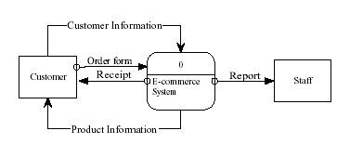
Figure 2.1 Context diagram
The next DFD is called the level 0 DFD. The level 0 diagram shows all the processes at the first level of numbering (i.e. process 1and 2), the data stores, external entities, and the data flows among them. The purpose of the level 0 DFD is to show all the major processes of the system and how they are interrelated.
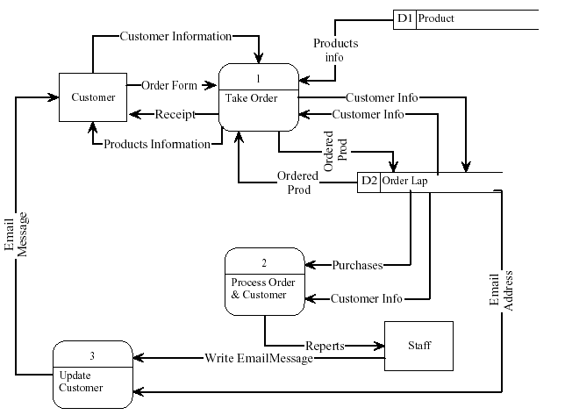
Figure 2.2 Level 0 DFD
2.4 Input / Output
Several inputs and outputs are required by the system to complete transactions successfully.
Inputs
- All the products available along with their prices are read from the 'product' table in the database and displayed on the website in the order form in the form of a drop down menu.
- Customer information inputted in the order form such as the customer's name, address, mobile, email etc. along with the desired product and date and time of delivery are inputs for the system.
- Staff members update the 'product' table with new products or delete products that are no longer available.
Outputs
- Website reads information from the database and displays a receipt for the customer.
- Staff members view reports such as customer information, delivery report etc. from the system.
- Staff members send emails to customers with all updated information about the company, services, and products.
CHAPTER 3: DESIGN
3.1 Physical model
The physical DFD contains the same components as the logical DFD (e.g. data stores, data flows). The basic difference between the two models is that a physical DFD contains additional details that describe how the system will be built.
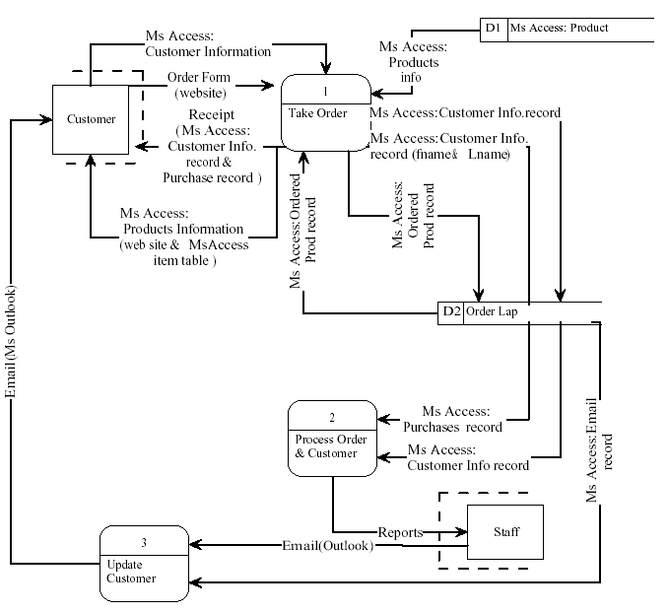
Figure 3.1 Physical DFD
3.2 Process Design
Three major processes were implemented in the system:
Process 1
The first process included taking the complete order form from the website and submitting it to the database. This process was called "Take Order" and is shown in the figure below.

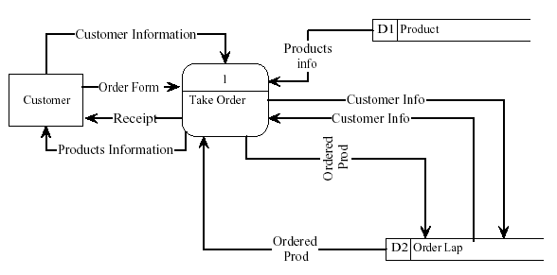
Figure 3.2 Process 1
Using the ASP language, the fields of the order form in the website were submitted according to their respective fields in the tables of the database.
The customer information (such as the name, telephone, address, etc.) was submitted to the corresponding fields in the "custinfo" table of the database. Here, the customer is given a unique auto number by the system to distinguish the customer from others.
The product purchased, its price, and delivery date filled in the order form were submitted to their corresponding fields in the "custinfo" table of the database, using the same customer id.
The process also included giving a receipt to the customer stating his/her name, the product ordered, its price, and the delivery date. Here, the website would read the information submitted to the "custinfo” table from the database and displaying it to the customer.
The database tables are explained in more detail later in this chapter.
Process 2
The second process was made for the staff members of the company to view the orders made and proceed with delivering the products accordingly.
After linking the two tables by means of relationships, a query could be generated to give every customer's information along with the product that he/she has ordered.
Different reports were made using the MS Access to give the staff members of the company the information needed to complete the order. Data was read from the "custinfo" tables to give these reports. The figure below illustrates this process.

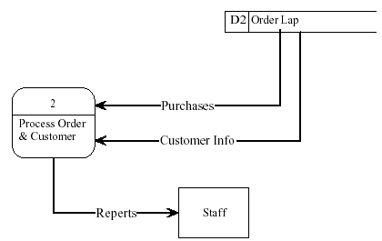
Figure 3.3 Process 2
Reports are explained in more detail later in this chapter.
Process 3
The third process was made so that staff members can update customers with related information such as new products or services offered by the company.

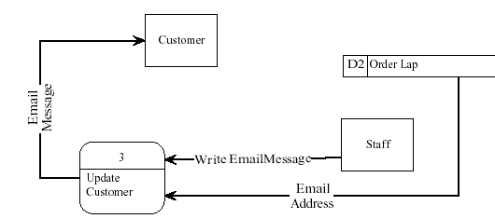
Figure 3.4 Process 3
3.3 Database Design
Database is a very important part of my project. I use it to keep track of users who will also use it indirectly (the users interact only with WebPages by using Active Server Pages which interact with the database) to keep track of results that will be stored in the database. In the design of database I should have entities (tables), attributes, data type, and identifier which also called keys (primary key, foreign key) that uniquely identifies an attribute and helps to make relationship between tables.

3.4 Tables
Three tables were constructed in the Ms Access database:
The first table was called 'item' and consisted of all the items displayed on the website for sale so that the website could read the related information from it.
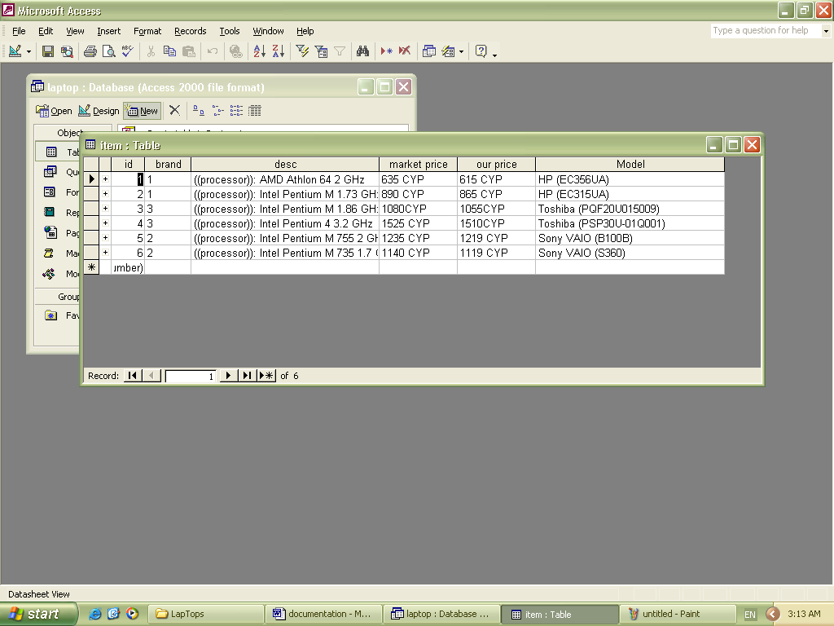
Figure 3.5 item table
Note that any changes made in this table will be affected in the website. Therefore an unlimited number of items can be added according to the company's requirements. (See Appendix B for the code used here)
The second table shown below is the 'custinfo' or customer information table. This includes all relevant customer information such as the customers' names, address, phone number, etc.
Every customer is given a unique auto number (defined as the primary key of that table) so that it can link to the purchase table described later in this chapter.
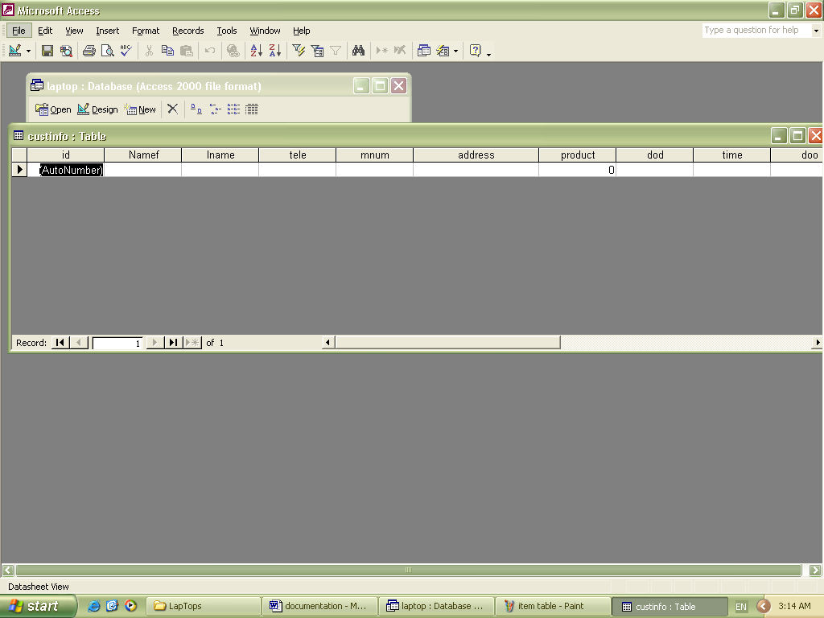
Figure 3.6 Customer information table
The third table was the ‘brands’. You found the name product of company.
The fourth table was the ‘manager’. You can make username and passward for admin web page.
Now that all the tables were in place, they were linked to the website to read and write information to and from it. (See Appendix B for relevant code).
After designing all the required tables and linking them to the website, relationships between them had to be established.
Relationships are associates between entities, and they are the links that connect the entities together. Every relationship has a parent entity (being the first entity in the relationship) and a child entity (being the second entity in the relationship).
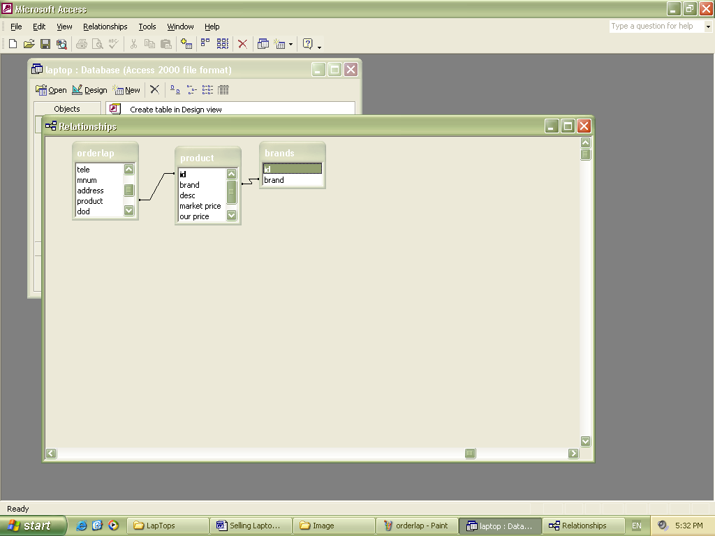
Figure 3.7 Relationship between tables
3.5 Queries
A query was designed to give the staff members of the company all the information they needed to process an order in one table. The queries are written in stuff member interface (ASP) (See Appendix A for relevant code).
3.6 Reports
Several reports were made for the company's staff members to view. The figures below illustrate these reports:
1- Customer Information Report
This report shows the company's customers' information. It shows the customers' names, addresses, telephones, Order details and emails.
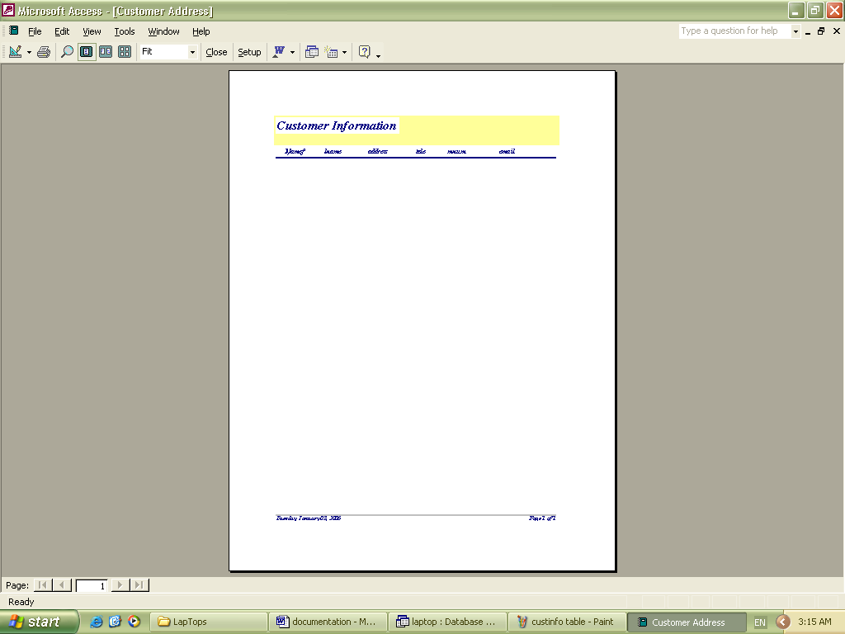
Figure 3.8 Customer Information Report
2- Delivery Report
This report is made for the delivery representative of the company. It shows the customers' names, addresses, telephones, the products ordered, and the amount due.
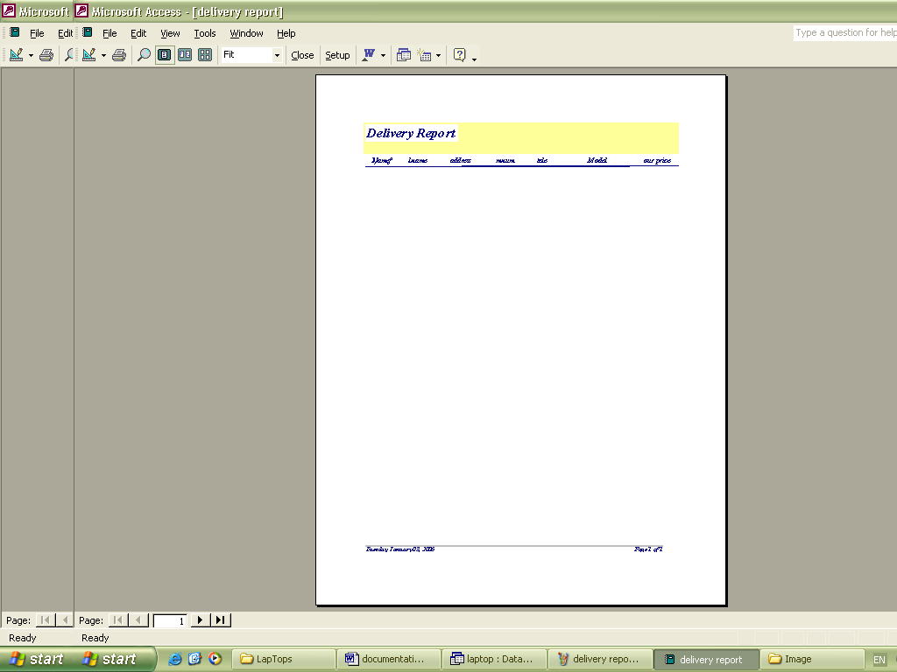
Figure 3.9 Delivery Report
3- Products' Description Report
This report shows all available products including their names and prices.
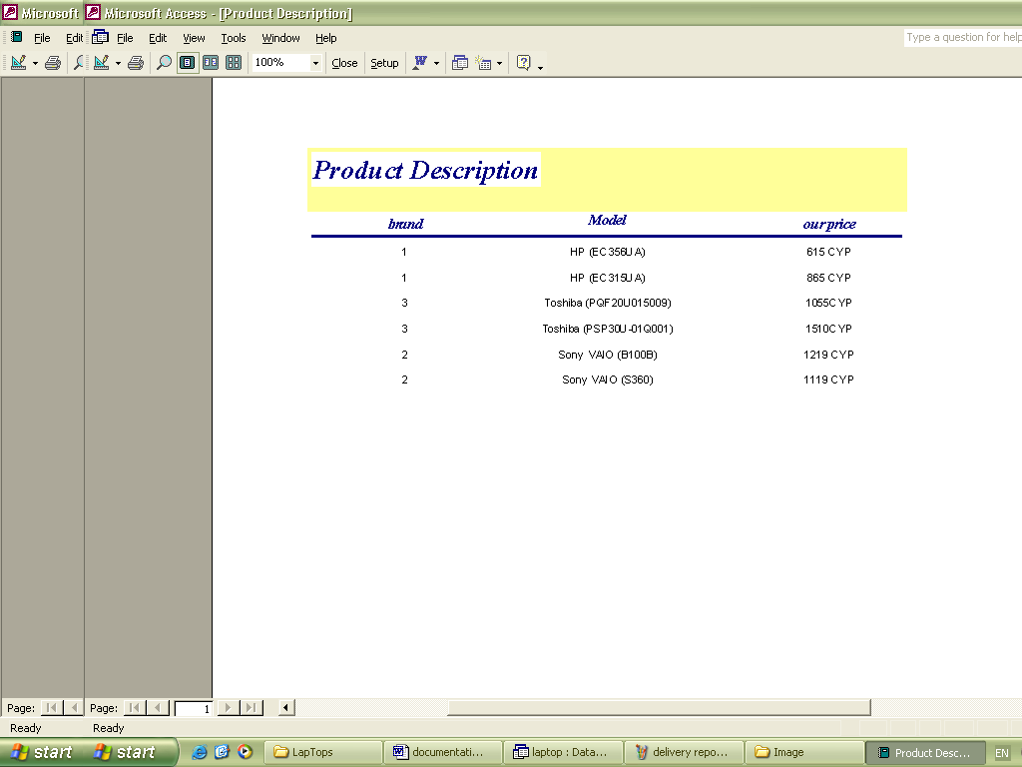
Figure 3.10 Product Description
3.7 Forms
I used the form option from the Ms Access Database to create a user friendly interface for the staff members of the company.
The form was created in the design view where I inserted different buttons that upon clicking enable the user to view or print several reports such as customer information, delivery report and so on.
After completing the form, I created a shortcut on the desktop so that users can automatically go the interface form I designed.
As the information stored in the database is very sensitive and confidential, I created a password so that only authorized staff personnel can access the interface created. The password created was 'elaptops' and the user is ‘neuadmin’. The figure below illustrates this process.

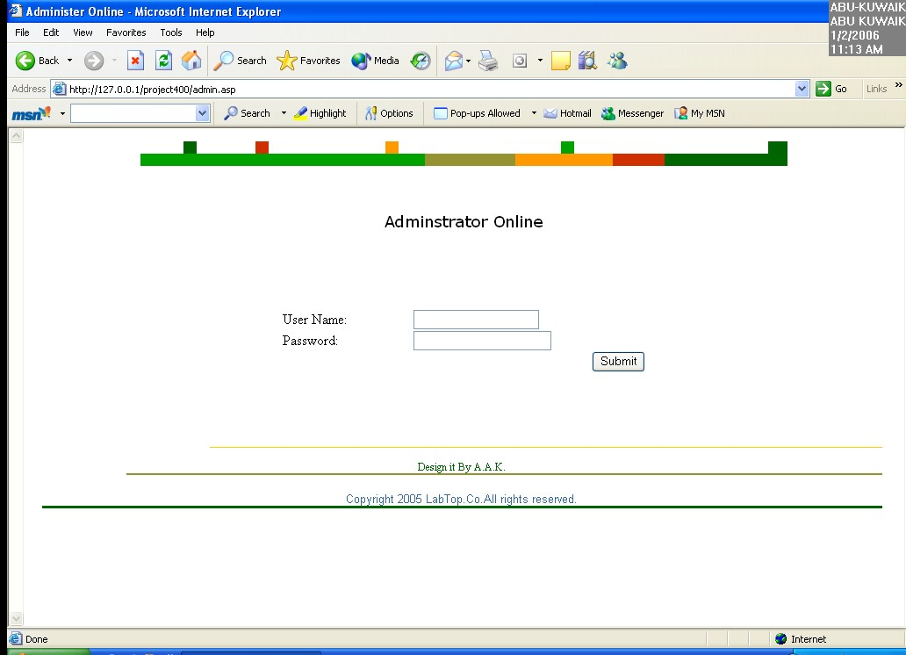
Figure 3.11 Adminstrator Online
Instructions on how to use this interface are later explained in Chapter 4 section 4.4.
CHAPTER 4: SYSTEM IMPLEMENTATION
4.1 Implementation
The system will be implemented in four phases:
Phase 1
The first phase will include designing the website and including all relevant information to it. Using Ms FrontPage and HTML, the web pages should be designed and hyperlinks should exist between them.
Phase 2
The second phase was to build the tables in the database. Two tables should be constructed. The product table should consist of all the products available for sale along with their prices and Ids.
The second table was the orderlap table and includes the customer id, product ordered id, date and time of delivery, etc. After the tables are constructed, relationships have to be place between the product table and the orderlap table.
Phase 3
This phase included linking the database and website together so that they can read and retrieve information from each other.
Using the ASP language, the order form and form reply page (which displays the receipt) should be connected to the database. The order form page should send the information it gathers from the customer and submit it to the database. The form reply page should read information from the database and display it as a receipt to the customer n the website.
Phase 4
The last phase is to develop a user interface for the employees of the company to interact with the database. First, reports should be generated using the reports option in the Ms Access software. The next step is to design the user interface using the form option in the Ms Access software according to the company's requirements.
4.2 Coding
As mentioned earlier, different software was used to construct the system. During the website development, most of the web pages were developed using Ms FrontPage. This software is user friendly software and most of the work was done using the tools in the Ms FrontPage software.
The coding started in the order form and form reply pages. In the order form page, I used VB Script to validate the fields in the form developed.
The ASP language was used to link the website to the Ms Access database so that they can send and receive information from one another.
(Refer to Appendix B for the VB Scripts and the ASP code; see Appendix C for the web pages coding in HTML)
4.3 Testing
4.3.1 Website Testing
The first step of my testing phase was to see if the website functioned correctly. This involved browsing through the website and making sure that all the information was correct and according to the company's requirements.
All the hyperlinks were tested to ensure their functionality was correct. In addition, the VB scripts on the order form were tested to see if they functioned as per requirements. These scripts were done on the client side to make sure that the customer didn’t leave any of the items on the form blank as all the information is needed by the company's staff to complete the transaction.
For example, if the customer forgot to write his/her first name, a pop up message would appear reminding the customer to fill in the specified field. The following figure illustrates the process.
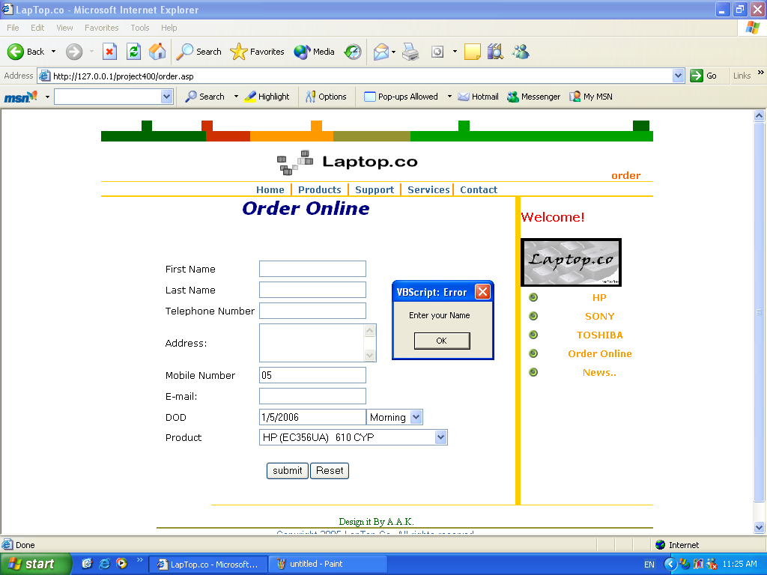
Figure 4.1 Website Testing
(Refer to Appendix B to see the codes of all the scripts)
4.3.2 Database Testing
In this phase I tested the relationships between the tables. I made several runs on queries and reports to ensure that they worked correctly.
I generated a query to view all the required information from all tables and got the following results successfully.
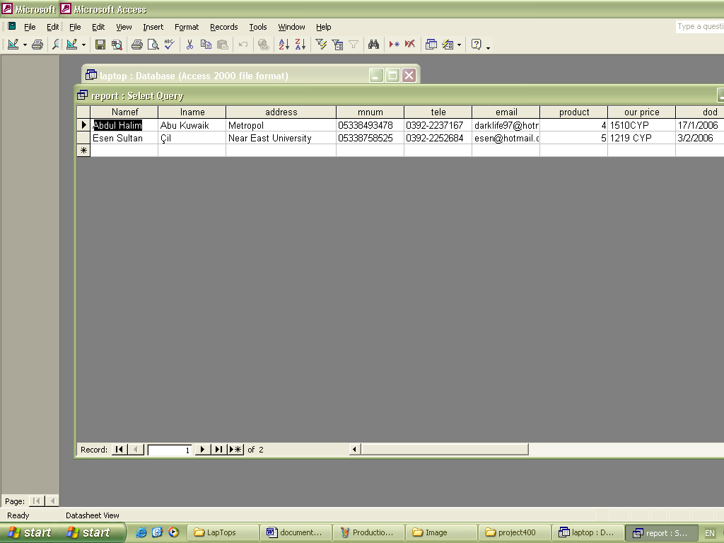
Figure 4.2 Database Testing
4.3.3 System Testing
Now that the website testing and database testing were completed, I had to test the entire system to ensure that the overall functionality was correct.
The order form on the website was filled with sample data.

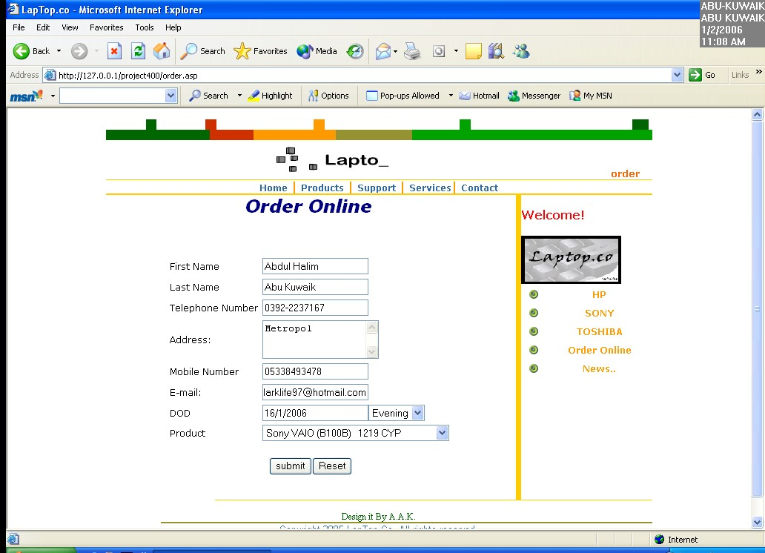
Figure 4.3.a System Testing
After submitting the order form I had to get the receipt in the form reply page. As shown in the figure below, the process was successful.
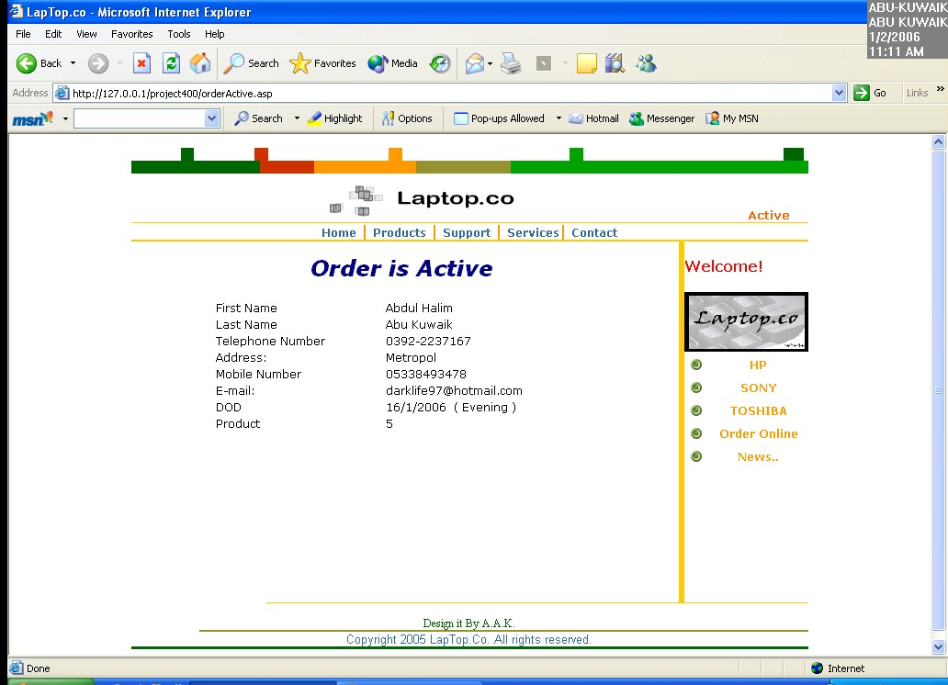
Figure 4.3.b System Testing
The next step was to see if the information submitted was entered correctly in the database.
4.4 User Manuals
After an order has been completed (i.e. the product was delivered to its customer), the company's representative will head back to the office and enter a cash sales receipt to the existing company’s system. Now that the corresponding customer record is not needed any more, it can be deleted from the database so that it doesn’t keep appearing in future reports.
To delete a customer or order from the database, the company's staff will open the customer information table 'custinfo', highlight the selected record to be deleted, right click on the mouse, and select the delete option, or simply press the delete key on the keyboard after highlighting the desired record. The figure below illustrated the process.
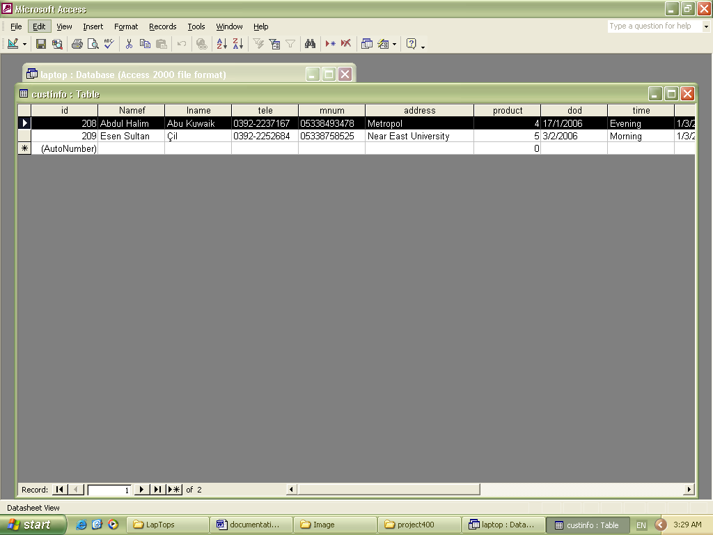
Figure 4.4 Deleting step1
A specific field is selected from the 'custoinfo' table.
After selecting the delete option, a pop up message appears confirming the deletion process.

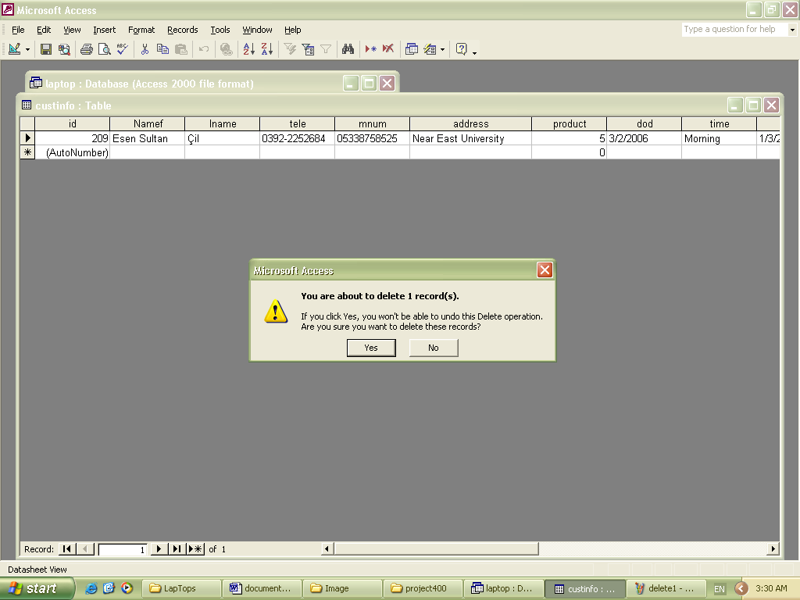
Figure 4.5 Deleting step2
This message asks the user if he/she is sure they want to delete the specified record. Clicking on "yes" will delete the record.

CONCLUSIONS
Achieved objectives
Now that the system was complete and the testing was finished, I will show whether or not the system achieved the hypotheses and technical objectives stated in chapter 1.
- The customer can easily navigate the website and browse for products of interest.
- After finding the desired product, the customer can fill out the order form with his/her personal information and the product desired.
- After submitting the order form to the database, the form reply page is shown to the customer displaying a receipt for the order made.
- The database is updated correctly with the order form information.
Open Questions
Due to the time constraint, there are still some unresolved issues within the system.
The customer can only order one product at a time from the website. Therefore if the customer wanted to buy two items for example, he/she would have to fill the order form twice.
The deletion of a customer's record after the transaction has been done is done manually by the company staff. This process should be done without the staff member opening the customer information table and should be done from the user interface menu.
The deletion of a customer's record after the transaction is made is not a good method to implement since the company should always have some records of all transactions that were made. Although all transactions are stored within the cashier system when the staff member checks in a receipt, it is better to have it done in a computerized manner. There should be another database where information is always stored just for the purpose of having a record of the transactions made.
Recommendations for Future Research
I’m currently researching different future plans that will better enhance the system as a whole. These plans include:
1) Implementing a search method on the website for customers to use. Customers will be able to type a word or phrase related to the website contents and get search results accordingly.
2) Constructing Java applets that can convert products' prices to different currencies for customers shopping from outside the Cyprus.
3) Implementing an authentication process where every customer is given a user name and password and can automatically sign in to view his/her purchasing history from the company. Customers will also receive discounts on products when they sign in.
4) Adding a shopping card process where customers can select several products to purchase. The customers' selections will automatically be updated in the order form.

REFERENCE

Reference: Book with more than one Auther
United States of America: John Wiley & Sons, Inc.
Elmasri & Navathe. (2004). Fundamentals of Database Systems. (4th ed.).
Dennis, A. & Wixom, B. H. (2003). System Analysis Design. (2nd ed.).
Reference: Web Pages
Compaq. (n.d). Retrieved December 13, 2005. from: http://www.compaq.com
Deakin. (n.d). Retrieved December 13, 2005. from: http://www.it.deakin.edu.au/display.asp
Dell. (n.d). Retrieved December 15, 2005. from: http://www.dell.com
Islandnet. (n.d). Retrieved December 11, 2005. from:
http://www.islandnet.com/~tmc/html/articles/datamodl.htm
Programmers Heaven. (n.d). Retrieved December 15, 2005. from:
http://www.programmersheaven.com/
Sony. (n.d). Retrieved December 21, 2005. from: http://www.sony.com
Free JavaScripts provided
By The JavaScript Source
JS-Examples.com

APENDIX A
Coding Explanation
The following VB Script code was used to make validations for all the items in the order form to ensure that the customer doesn’t forget and element since they are all needed to process the order.
<script language="vbscript">
sub checkme

if isnumeric(form1.T1.value) then
msgbox " Use letters for your name ",,"Error"
form1.t1.focus()
exit sub
end if

if (form1.T1.value="") then
msgbox " Enter your name ",,"Error"
form1.T1.focus()
exit sub
end if

if (form1.T2.value="") then
msgbox " Enter your initial ",,"Error"
form1.T2.focus()
exit sub
end if

if (form1.T3.value="") then
msgbox " Enter your last name ",,"Error"
form1.T3.focus()
exit sub
end if

if (form1.S1.value="") then
msgbox " Enter your address ",,"Error"
form1.S1.focus()
exit sub
end if

if (form1.T4.value="") then
msgbox " Enter your telephone number ",,"Error"
form1.T4.focus()
exit sub
end if

if (form1.T5.value="") then
msgbox " Enter your mobile number ",,"Error"
form1.T5.focus()
exit sub
end if

if (form1.T6.value="") then
msgbox " Enter your e-mail ",,"Error"
form1.T6.focus()
exit sub
end if

if (form1.T7.value="") then
msgbox " Enter your preferred time ",,"Error"
form1.t7.focus()
exit sub
end if

if (form1.D2.value="0") then
msgbox " Choose an item please ",,"Error"
form1.D2.focus()
exit sub
end if

order.submit()
end sub
</script>

The following code is used to read the product description in the dropdown menu in the form from the items table in the database:
<title>LapTop.co</title><%
set cn=createobject("ADODB.connection")
cn.open("provider=microsoft.jet.OLEDB.4.0;data source="& server.mappath("laptop.mdb"))
%>
<%
SQL="SELECT * FROM item "
set rs=createObject("ADODB.recordSet")
rs.Open SQL,cn,3,3
%>
<select size="1" name="D2">
<%while not rs.eof
a=rs("brand")
if a=1 then b="HP "
if a=2 then b="Sony "
if a=3 then b="Toshiba "
%>
<option value="<%=rs("id")%>"><%'=b%> <%=rs("model")%> &nbsp; <%=rs("our price")%></option>
<%rs.Movenext
wend%>
</select>

The following code is used to send information from the form at the website to the database:
<form method="POST" action="orderActive.asp">
The following code is used to retrieve items from the database and show it as a receipt to the customer:
<!--#include file="connection.asp"-->
<%
SQL="SELECT * FROM custinfo"
set rs=createObject("ADODB.recordSet")
rs.Open SQL,cn,3,3
a=Request("T1")
b=Request("T2")
c=Request("T3")
d=Request("T4")
e=Request("T5")
f=Request("T6")
g=Request("s1")
i=Request("d1")
h=Request("d2")

rs.addnew
rs("Namef") =a
rs("lname") =b
rs("tele") =c
rs("mnum") =d
rs("address") =g
rs("product") = h
rs("dod") =f
rs("time") =i
rs("email")=e
rs("doo") = Now()
rs.Update
%>

<HEAD>
<TITLE>SONY</TITLE>
<META content="Microsoft FrontPage 5.0" name=GENERATOR>
<META content="text/html; charset=iso-8859-1" http-equiv=Content-Type>
<STYLE type=text/css>
<!--
body { font-family:"Verdana", "Arial", "Helvetica", "sans-serif"; font-size: 9pt}
p { font-family:"Verdana", "Arial", "Helvetica", "sans-serif"; font-size: 9pt}
a:link { color: #0000FF; text-decoration: none}
a:visited { text-decoration: none}
a:hover { color: #FF0033; text-decoration: underline}
td { font-family: "Verdana", "Arial", "Helvetica", "sans-serif"; font-size: 9pt}
.CompanyName {font-family: "Verdana", "Arial", "Helvetica", "sans-serif"; font-size: 23pt}
-->
</STYLE>
</HEAD>
<BODY bgColor=#ffffff>
<DIV align=center>
<TABLE align=center border=0 cellPadding=0 cellSpacing=0 width="74%">
<TR>
<TD width="2%">&nbsp;</TD>
<TD width="2%">&nbsp;</TD>
<TD width="3%">&nbsp;</TD>
<TD bgColor=#006500 width="2%">&nbsp;</TD>
<TD width="5%">&nbsp;</TD>
<TD width="2%">&nbsp;</TD>
<TD width="2%">&nbsp;</TD>
<TD bgColor=#ce3000 width="2%">&nbsp;</TD>
<TD width="11%">&nbsp;</TD>
<TD width="2%">&nbsp;</TD>
<TD width="5%">&nbsp;</TD>
<TD bgColor=#ff9a00 width="2%">&nbsp;</TD>
<TD width="7%">&nbsp;</TD>
<TD width="2%">&nbsp;</TD>
<TD width="16%">&nbsp;</TD>
<TD bgColor=#00a200 width="2%">&nbsp;</TD>
<TD width="12%">&nbsp;</TD>
<TD width="2%">&nbsp;</TD>
<TD width="16%">&nbsp;</TD>
<TD bgColor=#006500 width="3%">&nbsp;</TD>
</TR>
</TABLE>
<TABLE border=0 cellPadding=0 cellSpacing=0 width="75%">
<TR>
<TD bgColor=#006600 height=13 rowSpan=2 width="19%">&nbsp;</TD>
<TD bgColor=#ce3000 rowSpan=2 width="8%">&nbsp;</TD>
<TD bgColor=#ff9900 height=13 rowSpan=2 width="15%">&nbsp;</TD>
<TD bgColor=#949231 height=13 rowSpan=2 width="14%">&nbsp;</TD>
<TD bgColor=#00a200 height=13 rowSpan=2 width="44%">&nbsp;</TD>
</TR>
<TR></TR>
</TABLE>
<TABLE border=0 cellPadding=0 cellSpacing=0 width="75%">
<TR>
<TD height=50><DIV align=center class=CompanyName>
<object classid="clsid:D27CDB6E-AE6D-11cf-96B8-444553540000" codebase="http://download.macromedia.com/pub/shockwave/cabs/flash/swflash.cab#version=6,0,29,0" width="354" height="53">
<param name="movie" value="image/me.swf">
<param name="quality" value="high">
<embed src="image/me.swf" quality="high" pluginspage="http://www.macromedia.com/go/getflashplayer" type="application/x-shockwave-flash" width="354" height="53"></embed></object>
</DIV></TD>
<TD vAlign=bottom><div align="center"><B><FONT color="#FF6600" size=2>Active</FONT></B></div></TD>
</TR>
<TR>
<TD colSpan=2>
<TABLE border=0 cellPadding=0 cellSpacing=0 width="100%">
<TR><TD bgColor=#ffcc00 height=1><DIV align=center><IMG height=1 src="./image/pixel.gif" width=1></DIV></TD></TR>
</TABLE>
</TD>
</TR>
<TR>
<TD colSpan=2 height=12>
<DIV align=center><B> <A href="./index.htm"><FONT color=#3169a5>Home</FONT></A><FONT color=#ff9900 size=3>
| </FONT> <a href="product.asp"><FONT color=#3169a5>Products</FONT></a><FONT color=#ff9900 size=3>
| </FONT> <A href="./link.htm"><FONT color=#3169a5>Support</FONT></A><FONT color=#ff9900 size=3>
| </FONT><a href="about.asp"><FONT color=#3169a5>Services</FONT></a><FONT color=#ff9900 size=3>|
</FONT> <A href="./contact.htm"><FONT color=#3169a5>Contact</FONT></A>
</B></DIV>
</TD>
</TR>
<TR>
<TD colSpan=2>
<DIV align=left>
<TABLE border=0 cellPadding=0 cellSpacing=0 width="100%">
<TR><TD bgColor=#ffcc00 height=2><DIV align=center><IMG height=1 src="./image/pixel.gif" width=1></DIV></TD></TR>
</TABLE>
</DIV>
</TD>
</TR>
</TABLE>
</DIV>
<TABLE align=center border=0 cellPadding=0 cellSpacing=0 width="75%">
<TR>
<TD colSpan=2 height=393 vAlign=top>
<p align="center"><BR><i><b><font size="5" color="#000080">Order is Active<br>
</font></b></i></p>
<div align="center">
<table border="0" width="70%" id="table1">
<tr>
<td>First Name</td>
<td><% =Request("T1")%></td>
</tr>
<tr>
<td>Last Name</td>
<td><% =Request("T2")%></td>
</tr>
<tr>
<td>Telephone Number</td>
<td><% =Request("T3")%></td>
</tr>
<tr>
<td>Address:</td>
<td><% =Request("S1")%></td>
</tr>
<tr>
<td>Mobile Number</td>
<td><% =Request("T4")%></td>
</tr>
<tr>
<td>E-mail:</td>
<td><% =Request("T5")%></td>
</tr>
<tr>

<td>DOD</td>

<td>
<% =Request("T6")%>
&nbsp;(
<% =Request("D1")%>
)
</tr>
<tr>
<td>Product</td>
<td><% =Request("D2")%></td>
</tr>
</table>
</div>
<p align="center">&nbsp;<TD bgColor=#ffcc00 height=393 vAlign=top width="1%"><IMG height=1 src="./image/pixel.gif" width=1></TD>
<TD bgColor=#ffffff height=393 vAlign=top width="18%">
<DIV align=right>
<P align=left><B><FONT color=#ff0000 size=3><BR>Welcome!</FONT></B></P>
<P align=left><B><FONT color=#ff0000><IMG height=65 src="./image/mylogo.gif" width=135></FONT></B> <!--#include file="cp.asp"--></P>
</DIV>

</TR>
<TR vAlign=top>
<TD colSpan=4>
<DIV align=right>
<TABLE border=0 cellPadding=0 cellSpacing=0 width="80%">
<TR bgColor=#ffcf00>
<TD height=1><DIV align=right><IMG height=1 src="./image/pixel.gif" width=1></DIV></TD>
</TR>
</TABLE>
</DIV>
<DIV align=center>
<BR>
<font color="#006400" face="Times New Roman, Times, serif">Design it
By A.A.K.</font> <BR>
</DIV>
<DIV align=right>
<TABLE border=0 cellPadding=0 cellSpacing=0 width="90%">
<TR bgColor=#949231>
<TD height=2><DIV align=right><IMG height=1 src="./image/pixel.gif" width=1></DIV></TD>
</TR>
</TABLE>
<DIV align=center> <FONT color=#3169a5 face="Arial, Helvetica, sans-serif" size=2>Copyright
2005 LapTop.Co. All rights reserved.</FONT><FONT color=#3169a5> </FONT><BR>
</DIV>
<TABLE border=0 cellPadding=0 cellSpacing=0 width="100%">
<TR bgColor=#006500>
<TD height=3><DIV align=right><IMG height=1 src="./image/pixel.gif" width=1></DIV></TD>
</TR>
</TABLE>
</DIV>
</TD>
</TR>
</TABLE>
</BODY>

APENDIX B (Website Coding)
Website Coding using HTML, VB Script, and ASP Languages:
Connection page:
<title>LapTop.co</title><%
set cn=createobject("ADODB.connection")
cn.open("provider=microsoft.jet.OLEDB.4.0;data source="& server.mappath("laptop.mdb"))
%>
Index Page:
<HTML>
<HEAD>
<SCRIPT LANGUAGE="JavaScript">
<!-- This script and many more are available free online at -->
<!-- The JavaScript Source!! http://javascript.internet.com -->
<!-- Begin
function scrollit(seed) {
var m1 = "WELCOME TO THE OFFICIAL LAPTOP.CO WEBSITE! ";
var m2 = "... WE HOPE THAT YOU WILL ENJOY SHOPPING WITH US. FOR ANY COMPALINTS OR SUGGESTIONS, PLEASE FEEL FREE TO CONTACT US AT ANY TIME. YOUR OPINIONIS IMPORTANTTO US. ";
var m3 = "";
var msg=m1+m2+m3;
var out = " ";
var c = 1;
if (seed > 100) {
seed--;
cmd="scrollit("+seed+")";
timerTwo=window.setTimeout(cmd,100);
}
else if (seed <= 100 && seed > 0) {
for (c=0 ; c < seed ; c++) {
out+=" ";
}
out+=msg;
seed--;
window.status=out;
cmd="scrollit("+seed+")";
timerTwo=window.setTimeout(cmd,100);
}
else if (seed <= 0) {
if (-seed < msg.length) {
out+=msg.substring(-seed,msg.length);
seed--;
window.status=out;
cmd="scrollit("+seed+")";
timerTwo=window.setTimeout(cmd,100);
}
else {
window.status=" ";
timerTwo=window.setTimeout("scrollit(100)",75);
}
}
}
// End -->
</SCRIPT>
<!-- STEP TWO: Add this onLoad event handler into the BODY tag -->
<BODY onLoad="scrollit(100)">
<!-- Script Size: 1.35 KB -->
<!--
This file retrieved from the JS-Examples archives
http://www.js-examples.com
1000s of free ready to use scripts, tutorials, forums.
Author: JS-Examples - http://www.js-examples.com/
-->
<STYLE>
.spanstyle {
position:absolute;
visibility:visible;
top:-50px;
font-size:12pt;
font-family:Verdana;
font-weight:bold;
color:black;
}
</STYLE>
<script>
var message="COM 400".split("");
var x;
var y;
var step=15;
var xpos=new Array();
var ypos=new Array();
function mouseMoved(e){
x = (document.layers) ? e.pageX : document.body.scrollLeft+event.clientX;
y = (document.layers) ? e.pageY : document.body.scrollTop+event.clientY;
}
function makesnake() {
var thisspan;
for (var i=message.length-1; i>=0; i--) {
xpos[i]=xpos[i-1]+step;
ypos[i]=ypos[i-1];
}
xpos[0]=x+step;
ypos[0]=y;
for (var i in message) {
if (document.all) {
thisspan = eval("span"+(i)+".style");
thisspan.posLeft=xpos[i];
thisspan.posTop=ypos[i];
} else if (document.layers) {
thisspan = eval("document.span"+i);
thisspan.left=xpos[i];
thisspan.top=ypos[i];
}
}
}
var timer = null;
function startSnake() {
for (var i in message) {
xpos[i]=-50;
ypos[i]=-50;
}
setTimeout('timer=setInterval("makesnake()",30);',1000);
}
startSnake();
for (var i in message) {
document.write("<span id='span"+i+"' class='spanstyle'>")
document.write(message[i]);
document.write("</span>");
}
if (document.layers) { document.captureEvents(Event.MOUSEMOVE); }
document.onmousemove = mouseMoved;
</script>
</head>
<TITLE>LapTop.co</TITLE>
<META content="Microsoft FrontPage 5.0" name=GENERATOR>
<META content="text/html; charset=iso-8859-1" http-equiv=Content-Type>
<STYLE type=text/css>
<!--
body { font-family:"Verdana", "Arial", "Helvetica", "sans-serif"; font-size: 9pt}
p { font-family:"Verdana", "Arial", "Helvetica", "sans-serif"; font-size: 9pt}
a:link { color: #0000FF; text-decoration: none}
a:visited { text-decoration: none}
a:hover { color: #FF0033; text-decoration: underline}
td { font-family: "Verdana", "Arial", "Helvetica", "sans-serif"; font-size: 9pt}
.CompanyName {font-family: "Verdana", "Arial", "Helvetica", "sans-serif"; font-size: 23pt}
-->
</STYLE>
</HEAD>
<BODY bgColor=#ffffff>
<DIV align=center>
<TABLE align=center border=0 cellPadding=0 cellSpacing=0 width="74%">
<TR>
<TD width="2%">&nbsp;</TD>
<TD width="2%">&nbsp;</TD>
<TD width="3%">&nbsp;</TD>
<TD bgColor=#006500 width="2%">&nbsp;</TD>
<TD width="5%">&nbsp;</TD>
<TD width="2%">&nbsp;</TD>
<TD width="2%">&nbsp;</TD>
<TD bgColor=#ce3000 width="2%">&nbsp;</TD>
<TD width="11%">&nbsp;</TD>
<TD width="2%">&nbsp;</TD>
<TD width="5%">&nbsp;</TD>
<TD bgColor=#ff9a00 width="2%">&nbsp;</TD>
<TD width="7%">&nbsp;</TD>
<TD width="2%">&nbsp;</TD>
<TD width="16%">&nbsp;</TD>
<TD bgColor=#00a200 width="2%">&nbsp;</TD>
<TD width="12%">&nbsp;</TD>
<TD width="2%">&nbsp;</TD>
<TD width="16%">&nbsp;</TD>
<TD bgColor=#006500 width="3%">&nbsp;</TD>
</TR>
</TABLE>
<TABLE border=0 cellPadding=0 cellSpacing=0 width="75%">
<TR>
<TD bgColor=#006600 height=13 rowSpan=2 width="19%">&nbsp;</TD>
<TD bgColor=#ce3000 rowSpan=2 width="8%">&nbsp;</TD>
<TD bgColor=#ff9900 height=13 rowSpan=2 width="15%">&nbsp;</TD>
<TD bgColor=#949231 height=13 rowSpan=2 width="14%">&nbsp;</TD>
<TD bgColor=#00a200 height=13 rowSpan=2 width="44%">&nbsp;</TD>
</TR>
<TR></TR>
</TABLE>
<TABLE border=0 cellPadding=0 cellSpacing=0 width="75%">
<TR>
<TD height=50><DIV align=center class=CompanyName>
<object classid="clsid:D27CDB6E-AE6D-11cf-96B8-444553540000" codebase="http://download.macromedia.com/pub/shockwave/cabs/flash/swflash.cab#version=6,0,29,0" width="354" height="53">
<param name="movie" value="image/me.swf">
<param name="quality" value="high">
<embed src="image/me.swf" quality="high" pluginspage="http://www.macromedia.com/go/getflashplayer" type="application/x-shockwave-flash" width="354" height="53"></embed></object>
</DIV></TD>
<TD vAlign=bottom><div align="center"><B><FONT color="#FF6600" size=2>Main </FONT></B></div></TD>
</TR>
<TR>
<TD colSpan=2>
<TABLE border=0 cellPadding=0 cellSpacing=0 width="100%">
<TR><TD bgColor=#ffcc00 height=1><DIV align=center>
<IMG src="./image/pixel.gif" width="1" height="1"></DIV></TD></TR>
</TABLE>
</TD>
</TR>
<TR>
<TD colSpan=2 height=12>
<DIV align=center><B> <A href="./index.htm"><FONT color=#3169a5>Home</FONT></A><FONT color=#ff9900 size=3>
| </FONT> <a href="product.asp"><FONT color=#3169a5>Products</FONT></a><FONT color=#ff9900 size=3>
| </FONT> <a href="support.asp"><FONT color=#3169a5>Support</FONT></a><FONT color=#ff9900 size=3>
| </FONT> <a href="about.asp"><FONT color=#3169a5>Services</FONT></a><FONT color=#ff9900 size=3>
| </FONT> <a href="contact.asp"><FONT color=#3169a5>Contact</FONT></a>
</B></DIV>
</TD>
</TR>
<TR>
<TD colSpan=2>
<DIV align=left>
<TABLE border=0 cellPadding=0 cellSpacing=0 width="100%">
<TR><TD bgColor=#ffcc00 height=2><DIV align=center>
<IMG src="./image/pixel.gif" width="1" height="1"></DIV></TD></TR>
</TABLE>
</DIV>
</TD>
</TR>
</TABLE>
</DIV>
<TABLE align=center border=0 cellPadding=0 cellSpacing=0 width="75%">
<TR>
<TD height=393 vAlign=center width=309><BR><IMG src="./image/back.gif" width="309" height="299"></TD>
<TD height=393 vAlign=top width="34%"><BR>
<TABLE bgColor=#ffffff border=0 cellPadding=0 cellSpacing=0 width="100%">
<TR>
<TD><DIV align=center><B><FONT color=#009900 face="Times New Roman, Times, serif" size=3><em>What's
New?</em></FONT></B></DIV></TD>
</TR>
</TABLE>
<P align="left"><FONT color=#FF6600 size="3" face="Times New Roman, Times, serif">
<em><strong>A Japanese company has developed technology to transmit a two-hour
movie in 0.5 seconds</strong></em></FONT></P>
<P><FONT color=#FF0000><em><font color="#000000" size="2" face="Courier New, Courier, mono"><strong><a href="news.asp">Read
more...</a></strong></font></em></FONT><FONT color=#000000><BR>
</FONT></P>
<TABLE bgColor=#ffffff border=0 cellPadding=0 cellSpacing=0 width="100%">
<TR>
<TD><DIV align=center><B><FONT color=#009900 face="Times New Roman, Times, serif" size=3><em>What's
New?</em></FONT></B></DIV></TD>
</TR>
</TABLE>
<P> <em><font color="#FF6600" size="3" face="Times New Roman, Times, serif"><strong>Sony
said on October 27 that its net profit almost halved in the three months
to September as falling prices of televisions</strong></font></em></P>
<P><FONT color=#000000 size="2" face="Courier New, Courier, mono"><em><strong><a href="news.asp">Read
more...</a></strong></em></FONT></P>
<P><FONT color=#000000><BR>
</FONT></P>
</TD>
<TD bgColor=#ffcc00 height=393 vAlign=top width=2>
<IMG src="./image/pixel.gif" width="1" height="1"></TD>
<TD bgColor=#ffffff height=393 vAlign=top width=135>
<DIV align=right>
<P align=left><B><FONT color=#ff0000 size=3><BR>Welcome!</FONT></B></P>
<P align=left><B><FONT color=#ff0000><IMG height=65 src="./image/mylogo.gif" width=135></FONT></B> <!--#include file="cp.asp"-->
</P>
<TABLE border=0 cellPadding=0 cellSpacing=0 width="100%">
<TR>
<TD height=25 width="20%" style="font-family: Verdana, Arial, Helvetica, sans-serif; font-size: 9pt">
<DIV align=center><IMG src="./image/point.gif" width="12" height="12"></DIV></TD>
<TD style="font-family: Verdana, Arial, Helvetica, sans-serif; font-size: 9pt"><DIV align=center><B>
<a href="sony.asp?id=1" style="color: #0000FF; text-decoration: none"><FONT color=#ff9c00>HP</FONT></a></B></DIV></TD>
</TR>
<TR>
<TD height=25 width="20%" style="font-family: Verdana, Arial, Helvetica, sans-serif; font-size: 9pt">
<DIV align=center><IMG src="./image/point.gif" width="12" height="12"></DIV></TD>
<TD style="font-family: Verdana, Arial, Helvetica, sans-serif; font-size: 9pt"><DIV align=center><B>
<a href="sony.asp?id=2" style="color: #0000FF; text-decoration: none"><FONT color=#ff9c00>SONY</FONT></a></B></DIV></TD>
</TR>
<TR>
<TD height=25 width="20%" style="font-family: Verdana, Arial, Helvetica, sans-serif; font-size: 9pt">
<DIV align=center><IMG src="./image/point.gif" width="12" height="12"></DIV></TD>
<TD style="font-family: Verdana, Arial, Helvetica, sans-serif; font-size: 9pt"><DIV align=center><B>
<a href="sony.asp?id=3" style="color: #0000FF; text-decoration: none"><FONT color=#ff9c00>TOSHIBA</FONT></a></B></DIV></TD>
</TR>
<TR>
<TD height=25 width="20%" style="font-family: Verdana, Arial, Helvetica, sans-serif; font-size: 9pt">
<DIV align=center><IMG src="./image/point.gif" width="12" height="12"></DIV></TD>
<TD style="font-family: Verdana, Arial, Helvetica, sans-serif; font-size: 9pt"><DIV align=center><B>
<a href="order.asp" style="color: #0000FF; text-decoration: none"><FONT color=#ff9c00>Order
Online </FONT></a></B></DIV></TD>
</TR>
<TR>
<TD height=25 width="20%" style="font-family: Verdana, Arial, Helvetica, sans-serif; font-size: 9pt">
<DIV align=center><IMG src="./image/point.gif" width="12" height="12"></DIV></TD>
<TD style="font-family: Verdana, Arial, Helvetica, sans-serif; font-size: 9pt"><DIV align=center>
<a href="news.asp"><font color="#FF9C00"><b>News..</b></font></a></DIV></TD>
</TR>
</TABLE>
</DIV>
</TD>
</TR>
<TR vAlign=top>
<TD colSpan=4>
<DIV align=right>
<TABLE border=0 cellPadding=0 cellSpacing=0 width="80%">
<TR bgColor=#ffcf00>
<TD height=1><DIV align=right><IMG src="./image/pixel.gif" width="1" height="1"></DIV></TD>
</TR>
</TABLE>
</DIV>
<DIV align=center>
<BR>
<font color="#006400" face="Times New Roman, Times, serif">Design it
By A.A.K</font> <BR>
</DIV>
<DIV align=right>
<TABLE border=0 cellPadding=0 cellSpacing=0 width="90%">
<TR bgColor=#949231>
<TD height=2><DIV align=right><IMG src="./image/pixel.gif" width="1" height="1"></DIV></TD>
</TR>
</TABLE>
<DIV align=center> <FONT color=#3169a5 face="Arial, Helvetica, sans-serif" size=2>Copyright
2005 LapTop.Co. All rights reserved.</FONT><FONT color=#3169a5> </FONT><BR>
</DIV>
<TABLE border=0 cellPadding=0 cellSpacing=0 width="100%">
<TR bgColor=#006500>
<TD height=3><DIV align=right><IMG src="./image/pixel.gif" width="1" height="1"></DIV></TD>
</TR>
</TABLE>
</DIV>
</TD>
</TR>
</TABLE>
</BODY>
</HTML>
About Page:
<HTML>
<HEAD>
<SCRIPT LANGUAGE="JavaScript">
<!-- This script and many more are available free online at -->
<!-- The JavaScript Source!! http://javascript.internet.com -->
<!-- Begin
function scrollit(seed) {
var m1 = "WELCOME TO THE OFFICIAL LAPTOP.CO WEBSITE! ";
var m2 = "... WE HOPE THAT YOU WILL ENJOY SHOPPING WITH US. FOR ANY COMPALINTS OR SUGGESTIONS, PLEASE FEEL FREE TO CONTACT US AT ANY TIME. YOUR OPINIONIS IMPORTANTTO US. ";
var m3 = "";
var msg=m1+m2+m3;
var out = " ";
var c = 1;
if (seed > 100) {
seed--;
cmd="scrollit("+seed+")";
timerTwo=window.setTimeout(cmd,100);
}
else if (seed <= 100 && seed > 0) {
for (c=0 ; c < seed ; c++) {
out+=" ";
}
out+=msg;
seed--;
window.status=out;
cmd="scrollit("+seed+")";
timerTwo=window.setTimeout(cmd,100);
}
else if (seed <= 0) {
if (-seed < msg.length) {
out+=msg.substring(-seed,msg.length);
seed--;
window.status=out;
cmd="scrollit("+seed+")";
timerTwo=window.setTimeout(cmd,100);
}
else {
window.status=" ";
timerTwo=window.setTimeout("scrollit(100)",75);
}
}
}
// End -->
</SCRIPT>
<!-- STEP TWO: Add this onLoad event handler into the BODY tag -->
<BODY onLoad="scrollit(100)">
<!-- Script Size: 1.35 KB -->
<!--
This file retrieved from the JS-Examples archives
http://www.js-examples.com
1000s of free ready to use scripts, tutorials, forums.
Author: JS-Examples - http://www.js-examples.com/
-->
<STYLE>
.spanstyle {
position:absolute;
visibility:visible;
top:-50px;
font-size:12pt;
font-family:Verdana;
font-weight:bold;
color:orange;
}
</STYLE>
<script>
var message="COM 400".split("");
var x;
var y;
var step=15;
var xpos=new Array();
var ypos=new Array();
function mouseMoved(e){
x = (document.layers) ? e.pageX : document.body.scrollLeft+event.clientX;
y = (document.layers) ? e.pageY : document.body.scrollTop+event.clientY;
}
function makesnake() {
var thisspan;
for (var i=message.length-1; i>=0; i--) {
xpos[i]=xpos[i-1]+step;
ypos[i]=ypos[i-1];
}
xpos[0]=x+step;
ypos[0]=y;
for (var i in message) {
if (document.all) {
thisspan = eval("span"+(i)+".style");
thisspan.posLeft=xpos[i];
thisspan.posTop=ypos[i];
} else if (document.layers) {
thisspan = eval("document.span"+i);
thisspan.left=xpos[i];
thisspan.top=ypos[i];
}
}
}
var timer = null;
function startSnake() {
for (var i in message) {
xpos[i]=-50;
ypos[i]=-50;
}
setTimeout('timer=setInterval("makesnake()",30);',1000);
}
startSnake();
for (var i in message) {
document.write("<span id='span"+i+"' class='spanstyle'>")
document.write(message[i]);
document.write("</span>");
}
if (document.layers) { document.captureEvents(Event.MOUSEMOVE); }
document.onmousemove = mouseMoved;
</script>
</head>
<TITLE>LapTop.co</TITLE>
<META content="Microsoft FrontPage 5.0" name=GENERATOR>
<META content="text/html; charset=iso-8859-1" http-equiv=Content-Type>
<STYLE type=text/css>
<!--
body { font-family:"Verdana", "Arial", "Helvetica", "sans-serif"; font-size: 9pt}
p { font-family:"Verdana", "Arial", "Helvetica", "sans-serif"; font-size: 9pt}
a:link { color: #0000FF; text-decoration: none}
a:visited { text-decoration: none}
a:hover { color: #FF0033; text-decoration: underline}
td { font-family: "Verdana", "Arial", "Helvetica", "sans-serif"; font-size: 9pt}
.CompanyName {font-family: "Verdana", "Arial", "Helvetica", "sans-serif"; font-size: 23pt}
li.MsoNormal
{mso-style-parent:"";
margin-bottom:.0001pt;
font-size:12.0pt;
font-family:"Times New Roman";
margin-left:0in; margin-right:0in; margin-top:0in}
-->
</STYLE>
</HEAD>
<BODY bgColor=#ffffff>
<DIV align=center>
<TABLE align=center border=0 cellPadding=0 cellSpacing=0 width="74%">
<TR>
<TD width="2%">&nbsp;</TD>
<TD width="2%">&nbsp;</TD>
<TD width="3%">&nbsp;</TD>
<TD bgColor=#006500 width="2%">&nbsp;</TD>
<TD width="5%">&nbsp;</TD>
<TD width="2%">&nbsp;</TD>
<TD width="2%">&nbsp;</TD>
<TD bgColor=#ce3000 width="2%">&nbsp;</TD>
<TD width="11%">&nbsp;</TD>
<TD width="2%">&nbsp;</TD>
<TD width="5%">&nbsp;</TD>
<TD bgColor=#ff9a00 width="2%">&nbsp;</TD>
<TD width="7%">&nbsp;</TD>
<TD width="2%">&nbsp;</TD>
<TD width="16%">&nbsp;</TD>
<TD bgColor=#00a200 width="2%">&nbsp;</TD>
<TD width="12%">&nbsp;</TD>
<TD width="2%">&nbsp;</TD>
<TD width="16%">&nbsp;</TD>
<TD bgColor=#006500 width="3%">&nbsp;</TD>
</TR>
</TABLE>
<TABLE border=0 cellPadding=0 cellSpacing=0 width="75%">
<TR>
<TD bgColor=#006600 height=13 rowSpan=2 width="19%">&nbsp;</TD>
<TD bgColor=#ce3000 rowSpan=2 width="8%">&nbsp;</TD>
<TD bgColor=#ff9900 height=13 rowSpan=2 width="15%">&nbsp;</TD>
<TD bgColor=#949231 height=13 rowSpan=2 width="14%">&nbsp;</TD>
<TD bgColor=#00a200 height=13 rowSpan=2 width="44%">&nbsp;</TD>
</TR>
<TR></TR>
</TABLE>
<TABLE border=0 cellPadding=0 cellSpacing=0 width="75%">
<TR>
<TD height=50><DIV align=center class=CompanyName>
<object classid="clsid:D27CDB6E-AE6D-11cf-96B8-444553540000" codebase="http://download.macromedia.com/pub/shockwave/cabs/flash/swflash.cab#version=6,0,29,0" width="354" height="53">
<param name="movie" value="image/me.swf">
<param name="quality" value="high">
<embed src="image/me.swf" quality="high" pluginspage="http://www.macromedia.com/go/getflashplayer" type="application/x-shockwave-flash" width="354" height="53"></embed></object>
</DIV></TD>
<TD vAlign=bottom><DIV align=right><B><font color="#FF6600" size="2">Services</font></B></DIV></TD>
</TR>
<TR>
<TD colSpan=2>
<TABLE border=0 cellPadding=0 cellSpacing=0 width="100%">
<TR><TD bgColor=#ffcc00 height=1><DIV align=center><IMG height=1 src="./image/pixel.gif" width=1></DIV></TD></TR>
</TABLE>
</TD>
</TR>
<TR>
<TD colSpan=2 height=12>
<p align="center"><B> <A href="./index.htm"><FONT color=#3169a5>Home</FONT></A><FONT color=#ff9900 size=3>
| </FONT> <A href="Product.asp"><FONT color=#3169a5>Products</FONT></A><FONT color=#ff9900 size=3>
| </FONT> <a href="support.asp"><FONT color=#3169a5>Support</FONT></a><FONT color=#ff9900 size=3>
| </FONT> <a href="about.asp"><FONT color=#3169a5>Services</FONT></a><FONT color=#ff9900 size=3>
| </FONT> <a href="contact.asp"><FONT color=#3169a5>Contact</FONT></a>
</B>
</TD>
</TR>
<TR>
<TD colSpan=2>
<DIV align=left>
<TABLE border=0 cellPadding=0 cellSpacing=0 width="100%">
<TR><TD bgColor=#ffcc00 height=2><DIV align=center><IMG height=1 src="./image/pixel.gif" width=1></DIV></TD></TR>
</TABLE>
</DIV>
</TD>
</TR>
</TABLE>
</DIV>
<TABLE align=center border=0 cellPadding=0 cellSpacing=0 width="75%">
<TR>
<TD colSpan=2 vAlign=top>
&nbsp;<DIV align=center style="width: 537; height: 329">&nbsp;
<p><b> <font size="5"><em><font color="#3399FF">Mission Statement</font></em><BR>
</font></b></p>
<ul style="MARGIN-BOTTOM: 0in" type="disc">
<li class="MsoNormal">
<p align="justify"><font size="4" face="Geneva, Arial, Helvetica, sans-serif"><span style="font-family: Arial">
Maintain and enhance our position in the market as leaders in E- commerce
in the Europe.</span> </font></li>
<li class="MsoNormal">
<p align="justify"><font size="4" face="Geneva, Arial, Helvetica, sans-serif"><span style="font-family: Arial">
Provide superior customer service to foster loyalty among both suppliers
and customers.</span> </font></li>
<li class="MsoNormal">
<p align="justify"><font size="4" face="Geneva, Arial, Helvetica, sans-serif"><span style="font-family: Arial">
Always strive to offer best value for suppliers and customers.</span>
</font></li>
<li class="MsoNormal">
<p align="justify"><font size="4" face="Geneva, Arial, Helvetica, sans-serif"><span style="font-family: Arial">
Show our commitment to help suppliers grow in their business.</span>
</font></li>
<li class="MsoNormal">
<p align="justify"><font size="4" face="Geneva, Arial, Helvetica, sans-serif"><span style="font-family: Arial">
Continuously look out for innovative and effective methods to increase
the number of suppliers, corporate customers and overall traffic.</span>
</font></li>
<li class="MsoNormal">
<p align="justify"><font size="4" face="Geneva, Arial, Helvetica, sans-serif"><span style="font-family: Arial">Be
the ideal marketplace for items and services.</span> </font></li>
</ul>
<p align="justify"><font face="Arial"><BR>
</font>
</DIV>
</TD>
<TD bgColor=#ffcc00 height=393 vAlign=top width=2><IMG height=1 src="./image/pixel.gif" width=1></TD>
<TD bgColor=#ffffff height=393 vAlign=top width=135>
<DIV align=right>
<P align=left><B><FONT color=#ff0000 size=3><BR>Welcome!</FONT></B></P>
<P align=left><B><FONT color=#ff0000><IMG height=65 src="./image/mylogo.gif" width=135></FONT></B> <!--#include file="cp.asp"--></P>
</DIV>
</TD>
</TR>
<TR vAlign=top>
<TD colSpan=4>
<DIV align=right>
<TABLE border=0 cellPadding=0 cellSpacing=0 width="80%">
<TR bgColor=#ffcf00>
<TD height=1><DIV align=right><IMG height=1 src="./image/pixel.gif" width=1></DIV></TD>
</TR>
</TABLE>
</DIV>
<DIV align=center>
<BR><FONT color=#006400 face="Times New Roman, Times, serif">Design it By
A.A.K.</FONT><BR>
</DIV>
<DIV align=right>
<TABLE border=0 cellPadding=0 cellSpacing=0 width="90%">
<TR bgColor=#949231>
<TD height=2><DIV align=right><IMG height=1 src="./image/pixel.gif" width=1></DIV></TD>
</TR>
</TABLE>
<DIV align=center>
<FONT color=#3169a5 face="Arial, Helvetica, sans-serif" size=2>Copyright 2005 LapTop.Co.All rights reserved.
</FONT><FONT color=#3169a5> </FONT><BR>
</DIV>
<TABLE border=0 cellPadding=0 cellSpacing=0 width="100%">
<TR bgColor=#006500>
<TD height=3><DIV align=right><IMG height=1 src="./image/pixel.gif" width=1></DIV></TD>
</TR>
</TABLE>
</DIV>
</TD>
</TR>
</TABLE>
</BODY>
</HTML>
News:
<!--#include file="connection.asp"-->
<HTML>
<HEAD>
<SCRIPT LANGUAGE="JavaScript">
<!-- This script and many more are available free online at -->
<!-- The JavaScript Source!! http://javascript.internet.com -->
<!-- Begin
function scrollit(seed) {
var m1 = "WELCOME TO THE OFFICIAL LAPTOP.CO WEBSITE! ";
var m2 = "... WE HOPE THAT YOU WILL ENJOY SHOPPING WITH US. FOR ANY COMPALINTS OR SUGGESTIONS, PLEASE FEEL FREE TO CONTACT US AT ANY TIME. YOUR OPINIONIS IMPORTANTTO US. ";
var m3 = "";
var msg=m1+m2+m3;
var out = " ";
var c = 1;
if (seed > 100) {
seed--;
cmd="scrollit("+seed+")";
timerTwo=window.setTimeout(cmd,100);
}
else if (seed <= 100 && seed > 0) {
for (c=0 ; c < seed ; c++) {
out+=" ";
}
out+=msg;
seed--;
window.status=out;
cmd="scrollit("+seed+")";
timerTwo=window.setTimeout(cmd,100);
}
else if (seed <= 0) {
if (-seed < msg.length) {
out+=msg.substring(-seed,msg.length);
seed--;
window.status=out;
cmd="scrollit("+seed+")";
timerTwo=window.setTimeout(cmd,100);
}
else {
window.status=" ";
timerTwo=window.setTimeout("scrollit(100)",75);
}
}
}
// End -->
</SCRIPT>
<!-- STEP TWO: Add this onLoad event handler into the BODY tag -->
<BODY onLoad="scrollit(100)">
<!-- Script Size: 1.35 KB -->
<!--
This file retrieved from the JS-Examples archives
http://www.js-examples.com
1000s of free ready to use scripts, tutorials, forums.
Author: JS-Examples - http://www.js-examples.com/
-->
<STYLE>
.spanstyle {
position:absolute;
visibility:visible;
top:-50px;
font-size:12pt;
font-family:Verdana;
font-weight:bold;
color:black;
}
</STYLE>
<script>
var message="COM 400".split("");
var x;
var y;
var step=15;
var xpos=new Array();
var ypos=new Array();
function mouseMoved(e){
x = (document.layers) ? e.pageX : document.body.scrollLeft+event.clientX;
y = (document.layers) ? e.pageY : document.body.scrollTop+event.clientY;
}
function makesnake() {
var thisspan;
for (var i=message.length-1; i>=0; i--) {
xpos[i]=xpos[i-1]+step;
ypos[i]=ypos[i-1];
}
xpos[0]=x+step;
ypos[0]=y;
for (var i in message) {
if (document.all) {
thisspan = eval("span"+(i)+".style");
thisspan.posLeft=xpos[i];
thisspan.posTop=ypos[i];
} else if (document.layers) {
thisspan = eval("document.span"+i);
thisspan.left=xpos[i];
thisspan.top=ypos[i];
}
}
}
var timer = null;
function startSnake() {
for (var i in message) {
xpos[i]=-50;
ypos[i]=-50;
}
setTimeout('timer=setInterval("makesnake()",30);',1000);
}
startSnake();
for (var i in message) {
document.write("<span id='span"+i+"' class='spanstyle'>")
document.write(message[i]);
document.write("</span>");
}
if (document.layers) { document.captureEvents(Event.MOUSEMOVE); }
document.onmousemove = mouseMoved;
</script>
</head>
<meta http-equiv="Content-Language" content="en-us">
<TITLE>SONY</TITLE>
<META content="Microsoft FrontPage 5.0" name=GENERATOR>
<META content="text/html; charset=windows-1252" http-equiv=Content-Type>
<STYLE type=text/css>
<!--
body { font-family:"Verdana", "Arial", "Helvetica", "sans-serif"; font-size: 9pt}
p { font-family:"Verdana", "Arial", "Helvetica", "sans-serif"; font-size: 9pt}
a:link { color: #0000FF; text-decoration: none}
a:visited { text-decoration: none}
a:hover { color: #FF0033; text-decoration: underline}
td { font-family: "Verdana", "Arial", "Helvetica", "sans-serif"; font-size: 9pt}
.CompanyName {font-family: "Verdana", "Arial", "Helvetica", "sans-serif"; font-size: 23pt}
-->
</STYLE>
</HEAD>
<BODY bgColor=#ffffff>
<DIV align=center>
<TABLE align=center border=0 cellPadding=0 cellSpacing=0 width="74%">
<TR>
<TD width="2%">&nbsp;</TD>
<TD width="2%">&nbsp;</TD>
<TD width="3%">&nbsp;</TD>
<TD bgColor=#006500 width="2%">&nbsp;</TD>
<TD width="5%">&nbsp;</TD>
<TD width="2%">&nbsp;</TD>
<TD width="2%">&nbsp;</TD>
<TD bgColor=#ce3000 width="2%">&nbsp;</TD>
<TD width="11%">&nbsp;</TD>
<TD width="2%">&nbsp;</TD>
<TD width="5%">&nbsp;</TD>
<TD bgColor=#ff9a00 width="2%">&nbsp;</TD>
<TD width="7%">&nbsp;</TD>
<TD width="2%">&nbsp;</TD>
<TD width="16%">&nbsp;</TD>
<TD bgColor=#00a200 width="2%">&nbsp;</TD>
<TD width="12%">&nbsp;</TD>
<TD width="2%">&nbsp;</TD>
<TD width="16%">&nbsp;</TD>
<TD bgColor=#006500 width="3%">&nbsp;</TD>
</TR>
</TABLE>
<TABLE border=0 cellPadding=0 cellSpacing=0 width="75%">
<TR>
<TD bgColor=#006600 height=13 rowSpan=2 width="19%">&nbsp;</TD>
<TD bgColor=#ce3000 rowSpan=2 width="8%">&nbsp;</TD>
<TD bgColor=#ff9900 height=13 rowSpan=2 width="15%">&nbsp;</TD>
<TD bgColor=#949231 height=13 rowSpan=2 width="14%">&nbsp;</TD>
<TD bgColor=#00a200 height=13 rowSpan=2 width="44%">&nbsp;</TD>
</TR>
<TR></TR>
</TABLE>
<TABLE border=0 cellPadding=0 cellSpacing=0 width="75%">
<TR>
<TD height=50><DIV align=center class=CompanyName>
<object classid="clsid:D27CDB6E-AE6D-11cf-96B8-444553540000" codebase="http://download.macromedia.com/pub/shockwave/cabs/flash/swflash.cab#version=6,0,29,0" width="354" height="53">
<param name="movie" value="image/me.swf">
<param name="quality" value="high">
<embed src="image/me.swf" quality="high" pluginspage="http://www.macromedia.com/go/getflashplayer" type="application/x-shockwave-flash" width="354" height="53"></embed></object>
</DIV></TD>
<TD vAlign=bottom><div align="center"><B><FONT color="#FF6600" size=2>News..</FONT></B></div></TD>
</TR>
<TR>
<TD colSpan=2>
<TABLE border=0 cellPadding=0 cellSpacing=0 width="100%">
<TR><TD bgColor=#ffcc00 height=1><DIV align=center><IMG height=1 src="./image/pixel.gif" width=1></DIV></TD></TR>
</TABLE>
</TD>
</TR>
<TR>
<TD colSpan=2 height=12>
<DIV align=center><B> <A href="./index.htm"><FONT color=#3169a5>Home</FONT></A><FONT color=#ff9900 size=3>
| </FONT> <a href="product.asp"><FONT color=#3169a5>Products</FONT></a><FONT color=#ff9900 size=3>
| </FONT> <a href="support.asp"><FONT color=#3169a5>Support</FONT></a><FONT color=#ff9900 size=3>
| </FONT><a href="about.asp"><FONT color=#3169a5>Services</FONT></a><FONT color=#ff9900 size=3>|
</FONT> <a href="contact.asp"><FONT color=#3169a5>Contact</FONT></a>
</B></DIV>
</TD>
</TR>
<TR>
<TD colSpan=2>
<DIV align=left>
<TABLE border=0 cellPadding=0 cellSpacing=0 width="100%">
<TR><TD bgColor=#ffcc00 height=2><DIV align=center><IMG height=1 src="./image/pixel.gif" width=1></DIV></TD></TR>
</TABLE>
</DIV>
</TD>
</TR>
</TABLE>
</DIV>
<TABLE align=center border=0 cellPadding=0 cellSpacing=0 width="75%">
<TR>
<TD colSpan=2 height=393 vAlign=top>
<p align="center"><font size="5" color="#3399FF"><b><i>News..</i></b></font></p>
<p align="left"><font color="#000066" size="3"><em><strong>Movie downloaded in 0.5
seconds </strong> </em></font></p>
<p><font color="#FF6600" size="3" face="Times New Roman, Times, serif"><strong>TOKYO
- A Japanese company has developed technology to transmit a two-hour movie
in 0.5 seconds, the world's fastest speed achieved with fiber-optic cables
in the field. Kansai Electric said on October 27 that it used fiber-optic
cables on power-transmitting steel towers to achieve the speed of one terabit
per second, which is more than 100 times faster than inter-city data transmissions
currently in use, a spokesman said. </strong></font></p>
<p>---------------------------------------------------------------------------</p>
<p><font color="#000066" size="3"><em><strong>Sony profit slides under Brit
boss</strong> </em></font></p>
<p><font color="#FF6600"><strong><font size="3" face="Times New Roman, Times, serif">TOKYO - Sony said on October
27 that its net profit almost halved in the three months to September as
falling prices of televisions and other electronics goods hit the struggling
Japanese icon's bottom line. Sony, which under its new boss, British-born
Howard Stringer, last month announced a major overhaul of the business including
10,000 job cuts, left its full-year forecast unchanged at a net loss of
10 billion yen. </font></strong></font></p>
<p><font size="3" face="Times New Roman, Times, serif"><strong><font color="#FF6600">Sony posted a net profit of
28.5 billion yen for the second quarter of its financial year, down 46.5
percent from a year earlier. The company has been hit by fierce competition
in key markets such as televisions that has driven down prices for plasma
and liquid crystal screens. Stringer, the first foreigner to take the helm
at Sony in its six-decade history, plans to dispose of a swathe of assets
and axe 11 manufacturing plants and focus on revitalizing the core electronics
business. </font></strong></font><br>
</p>
<p align="left">&nbsp;</p>
<p align="center">&nbsp;</p>
<p align="center"> <br>
<TD bgColor=#ffcc00 height=393 vAlign=top width="1%"><IMG height=1 src="./image/pixel.gif" width=1></TD>
<TD bgColor=#ffffff height=393 vAlign=top width="24%">
<DIV align=right>
<P align=left><B><FONT color=#ff0000 size=3><BR>Welcome!</FONT></B></P>
<P align=left><B><FONT color=#ff0000><IMG height=65 src="./image/mylogo.gif" width=135></FONT></B> <!--#include file="cp.asp"--></P>
</DIV>
</TR>
<TR vAlign=top>
<TD colSpan=4>
<DIV align=right>
<TABLE border=0 cellPadding=0 cellSpacing=0 width="80%">
<TR bgColor=#ffcf00>
<TD height=1><DIV align=right><IMG height=1 src="./image/pixel.gif" width=1></DIV></TD>
</TR>
</TABLE>
</DIV>
<DIV align=center>
<BR>
<font color="#006400" face="Times New Roman, Times, serif">Design it
By <span lang="tr">A.A.K.</span></font> <BR>
</DIV>
<DIV align=right>
<TABLE border=0 cellPadding=0 cellSpacing=0 width="90%">
<TR bgColor=#949231>
<TD height=2><DIV align=right><IMG height=1 src="./image/pixel.gif" width=1></DIV></TD>
</TR>
</TABLE>
<DIV align=center> <FONT color=#3169a5 face="Arial, Helvetica, sans-serif" size=2>Copyright
2005 LapTop.<span lang="tr">C</span>o.<span lang="tr"> </span>All rights reserved.</FONT><FONT color=#3169a5> </FONT><BR>
</DIV>
<TABLE border=0 cellPadding=0 cellSpacing=0 width="100%">
<TR bgColor=#006500>
<TD height=3><DIV align=right><IMG height=1 src="./image/pixel.gif" width=1></DIV></TD>
</TR>
</TABLE>
</DIV>
</TD>
</TR>
</TABLE>
</BODY>
</HTML>
Product:
<!--#include file="connection.asp"-->
<HTML>
<HEAD>
<SCRIPT LANGUAGE="JavaScript">
<!-- This script and many more are available free online at -->
<!-- The JavaScript Source!! http://javascript.internet.com -->
<!-- Begin
function scrollit(seed) {
var m1 = "WELCOME TO THE OFFICIAL LAPTOP.CO WEBSITE! ";
var m2 = "... WE HOPE THAT YOU WILL ENJOY SHOPPING WITH US. FOR ANY COMPALINTS OR SUGGESTIONS, PLEASE FEEL FREE TO CONTACT US AT ANY TIME. YOUR OPINIONIS IMPORTANTTO US. ";
var m3 = "";
var msg=m1+m2+m3;
var out = " ";
var c = 1;
if (seed > 100) {
seed--;
cmd="scrollit("+seed+")";
timerTwo=window.setTimeout(cmd,100);
}
else if (seed <= 100 && seed > 0) {
for (c=0 ; c < seed ; c++) {
out+=" ";
}
out+=msg;
seed--;
window.status=out;
cmd="scrollit("+seed+")";
timerTwo=window.setTimeout(cmd,100);
}
else if (seed <= 0) {
if (-seed < msg.length) {
out+=msg.substring(-seed,msg.length);
seed--;
window.status=out;
cmd="scrollit("+seed+")";
timerTwo=window.setTimeout(cmd,100);
}
else {
window.status=" ";
timerTwo=window.setTimeout("scrollit(100)",75);
}
}
}
// End -->
</SCRIPT>
<!-- STEP TWO: Add this onLoad event handler into the BODY tag -->
<BODY onLoad="scrollit(100)">
<!-- Script Size: 1.35 KB -->
<!--
This file retrieved from the JS-Examples archives
http://www.js-examples.com
1000s of free ready to use scripts, tutorials, forums.
Author: JS-Examples - http://www.js-examples.com/
-->
<STYLE>
.spanstyle {
position:absolute;
visibility:visible;
top:-50px;
font-size:12pt;
font-family:Verdana;
font-weight:bold;
color:gray;
}
</STYLE>
<script>
var message="COM 400".split("");
var x;
var y;
var step=15;
var xpos=new Array();
var ypos=new Array();
function mouseMoved(e){
x = (document.layers) ? e.pageX : document.body.scrollLeft+event.clientX;
y = (document.layers) ? e.pageY : document.body.scrollTop+event.clientY;
}
function makesnake() {
var thisspan;
for (var i=message.length-1; i>=0; i--) {
xpos[i]=xpos[i-1]+step;
ypos[i]=ypos[i-1];
}
xpos[0]=x+step;
ypos[0]=y;

for (var i in message) {
if (document.all) {
thisspan = eval("span"+(i)+".style");
thisspan.posLeft=xpos[i];
thisspan.posTop=ypos[i];
} else if (document.layers) {
thisspan = eval("document.span"+i);
thisspan.left=xpos[i];
thisspan.top=ypos[i];
}
}
}
var timer = null;
function startSnake() {
for (var i in message) {
xpos[i]=-50;
ypos[i]=-50;
}
setTimeout('timer=setInterval("makesnake()",30);',1000);
}
startSnake();
for (var i in message) {
document.write("<span id='span"+i+"' class='spanstyle'>")
document.write(message[i]);
document.write("</span>");
}
if (document.layers) { document.captureEvents(Event.MOUSEMOVE); }
document.onmousemove = mouseMoved;
</script>
</head>
<meta http-equiv="Content-Language" content="en-us">
<TITLE>SONY</TITLE>
<META content="Microsoft FrontPage 5.0" name=GENERATOR>
<META content="text/html; charset=windows-1252" http-equiv=Content-Type>
<STYLE type=text/css>
<!--
body { font-family:"Verdana", "Arial", "Helvetica", "sans-serif"; font-size: 9pt}
p { font-family:"Verdana", "Arial", "Helvetica", "sans-serif"; font-size: 9pt}
a:link { color: #0000FF; text-decoration: none}
a:visited { text-decoration: none}
a:hover { color: #FF0033; text-decoration: underline}
td { font-family: "Verdana", "Arial", "Helvetica", "sans-serif"; font-size: 9pt}
.CompanyName {font-family: "Verdana", "Arial", "Helvetica", "sans-serif"; font-size: 23pt}
-->
</STYLE>
</HEAD>
<BODY bgColor=#ffffff>
<DIV align=center>
<TABLE align=center border=0 cellPadding=0 cellSpacing=0 width="74%">
<TR>
<TD width="2%">&nbsp;</TD>
<TD width="2%">&nbsp;</TD>
<TD width="3%">&nbsp;</TD>
<TD bgColor=#006500 width="2%">&nbsp;</TD>
<TD width="5%">&nbsp;</TD>
<TD width="2%">&nbsp;</TD>
<TD width="2%">&nbsp;</TD>
<TD bgColor=#ce3000 width="2%">&nbsp;</TD>
<TD width="11%">&nbsp;</TD>
<TD width="2%">&nbsp;</TD>
<TD width="5%">&nbsp;</TD>
<TD bgColor=#ff9a00 width="2%">&nbsp;</TD>
<TD width="7%">&nbsp;</TD>
<TD width="2%">&nbsp;</TD>
<TD width="16%">&nbsp;</TD>
<TD bgColor=#00a200 width="2%">&nbsp;</TD>
<TD width="12%">&nbsp;</TD>
<TD width="2%">&nbsp;</TD>
<TD width="16%">&nbsp;</TD>
<TD bgColor=#006500 width="3%">&nbsp;</TD>
</TR>
</TABLE>
<TABLE border=0 cellPadding=0 cellSpacing=0 width="75%">
<TR>
<TD bgColor=#006600 height=13 rowSpan=2 width="19%">&nbsp;</TD>
<TD bgColor=#ce3000 rowSpan=2 width="8%">&nbsp;</TD>
<TD bgColor=#ff9900 height=13 rowSpan=2 width="15%">&nbsp;</TD>
<TD bgColor=#949231 height=13 rowSpan=2 width="14%">&nbsp;</TD>
<TD bgColor=#00a200 height=13 rowSpan=2 width="44%">&nbsp;</TD>
</TR>
<TR></TR>
</TABLE>
<TABLE border=0 cellPadding=0 cellSpacing=0 width="75%">
<TR>
<TD height=50><DIV align=center class=CompanyName>
<object classid="clsid:D27CDB6E-AE6D-11cf-96B8-444553540000" codebase="http://download.macromedia.com/pub/shockwave/cabs/flash/swflash.cab#version=6,0,29,0" width="354" height="53">
<param name="movie" value="image/me.swf">
<param name="quality" value="high">
<embed src="image/me.swf" quality="high" pluginspage="http://www.macromedia.com/go/getflashplayer" type="application/x-shockwave-flash" width="354" height="53"></embed></object>
</DIV></TD>
<TD vAlign=bottom><div align="center"><B><FONT color="#FF6600" size=2>item</FONT></B></div></TD>
</TR>
<TR>
<TD colSpan=2>
<TABLE border=0 cellPadding=0 cellSpacing=0 width="100%">
<TR><TD bgColor=#ffcc00 height=1><DIV align=center><IMG height=1 src="./image/pixel.gif" width=1></DIV></TD></TR>
</TABLE>
</TD>
</TR>
<TR>
<TD colSpan=2 height=12>
<DIV align=center><B> <A href="./index.htm"><FONT color=#3169a5>Home</FONT></A><FONT color=#ff9900 size=3>
| </FONT> <a href="product.asp"><FONT color=#3169a5>Products</FONT></a><FONT color=#ff9900 size=3>
| </FONT> <a href="support.asp"><FONT color=#3169a5>Support</FONT></a><FONT color=#ff9900 size=3>
| </FONT><a href="about.asp"><FONT color=#3169a5>Services</FONT></a><FONT color=#ff9900 size=3>|
</FONT> <a href="contact.asp"><FONT color=#3169a5>Contact</FONT></a>
</B></DIV>
</TD>
</TR>
<TR>
<TD colSpan=2>
<DIV align=left>
<TABLE border=0 cellPadding=0 cellSpacing=0 width="100%">
<TR><TD bgColor=#ffcc00 height=2><DIV align=center><IMG height=1 src="./image/pixel.gif" width=1></DIV></TD></TR>
</TABLE>
</DIV>
</TD>
</TR>
</TABLE>
</DIV>
<TABLE align=center border=0 cellPadding=0 cellSpacing=0 width="75%">
<TR>
<TD colSpan=2 height=393 vAlign=top>
<p align="center"><font size="5" color="#3399FF"><b><i>Products</i></b></font></p>
<p align="center">&nbsp;</p>
<p align="center">
<a href="sony.asp?id=1"><img src="HP%20Logo.gif" width="64" height="55" border="0"></a> <p align="center">
<a href="sony.asp?id=2"><img border="0" src="sony.gif"></a>
<p align="center"> <a href="sony.asp?id=3"><img src="TOPSIBA.gif" width="96" height="31" border="0"></a><br>
<TD bgColor=#ffcc00 height=393 vAlign=top width="1%"><IMG height=1 src="./image/pixel.gif" width=1></TD>
<TD bgColor=#ffffff height=393 vAlign=top width="24%">
<DIV align=right>
<P align=left><B><FONT color=#ff0000 size=3><BR>Welcome!</FONT></B></P>
<P align=left><B><FONT color=#ff0000><IMG height=65 src="./image/mylogo.gif" width=135></FONT></B> <!--#include file="cp.asp"--></P>
</DIV>
</TR>
<TR vAlign=top>
<TD colSpan=4>
<DIV align=right>
<TABLE border=0 cellPadding=0 cellSpacing=0 width="80%">
<TR bgColor=#ffcf00>
<TD height=1><DIV align=right><IMG height=1 src="./image/pixel.gif" width=1></DIV></TD>
</TR>
</TABLE>
</DIV>
<DIV align=center>
<BR>
<font color="#006400" face="Times New Roman, Times, serif">Design it
By </font><span lang="tr">
<font face="Times New Roman, Times, serif" color="#006400">A.A.K.</font></span> <BR>
</DIV>
<DIV align=right>
<TABLE border=0 cellPadding=0 cellSpacing=0 width="90%">
<TR bgColor=#949231>
<TD height=2><DIV align=right><IMG height=1 src="./image/pixel.gif" width=1></DIV></TD>
</TR>
</TABLE>
<DIV align=center> <FONT color=#3169a5 face="Arial, Helvetica, sans-serif" size=2>Copyright
2005 LapTop.<span lang="tr">C</span>o.<span lang="tr"> </span>All rights reserved.</FONT><FONT color=#3169a5> </FONT><BR>
</DIV>
<TABLE border=0 cellPadding=0 cellSpacing=0 width="100%">
<TR bgColor=#006500>
<TD height=3><DIV align=right><IMG height=1 src="./image/pixel.gif" width=1></DIV></TD>
</TR>
</TABLE>
</DIV>
</TD>
</TR>
</TABLE>
</BODY>
</HTML>
Support:
<!--#include file="connection.asp"-->
<%
SQL="SELECT * FROM custinfo"
set rs=createObject("ADODB.recordSet")
rs.Open SQL,cn,3,3
a=Request("T1")
b=Request("T2")
c=Request("T3")
d=Request("T4")
e=Request("T5")
f=Request("T6")
g=Request("s1")
i=Request("d1")
h=Request("d2")

rs.addnew
rs("Namef") =a
rs("lname") =b
rs("tele") =c
rs("mnum") = d
rs("address") = g
rs("product") =h
rs("dod") = f
rs("time") =i
rs("email")=e
rs("doo") = Now()
rs.Update
%>
<HEAD>
<SCRIPT LANGUAGE="JavaScript">
<!-- This script and many more are available free online at -->
<!-- The JavaScript Source!! http://javascript.internet.com -->
<!-- Begin
function scrollit(seed) {
var m1 = "WELCOME TO THE OFFICIAL LAPTOP.CO WEBSITE! ";
var m2 = "... WE HOPE THAT YOU WILL ENJOY SHOPPING WITH US. FOR ANY COMPALINTS OR SUGGESTIONS, PLEASE FEEL FREE TO CONTACT US AT ANY TIME. YOUR OPINIONIS IMPORTANTTO US. ";
var m3 = "";
var msg=m1+m2+m3;
var out = " ";
var c = 1;
if (seed > 100) {
seed--;
cmd="scrollit("+seed+")";
timerTwo=window.setTimeout(cmd,100);
}
else if (seed <= 100 && seed > 0) {
for (c=0 ; c < seed ; c++) {
out+=" ";
}
out+=msg;
seed--;
window.status=out;
cmd="scrollit("+seed+")";
timerTwo=window.setTimeout(cmd,100);
}
else if (seed <= 0) {
if (-seed < msg.length) {
out+=msg.substring(-seed,msg.length);
seed--;
window.status=out;
cmd="scrollit("+seed+")";
timerTwo=window.setTimeout(cmd,100);
}
else {
window.status=" ";
timerTwo=window.setTimeout("scrollit(100)",75);
}
}
}
// End -->
</SCRIPT>
<!-- STEP TWO: Add this onLoad event handler into the BODY tag -->
<BODY onLoad="scrollit(100)">
<!-- Script Size: 1.35 KB -->
<!--
This file retrieved from the JS-Examples archives
http://www.js-examples.com
1000s of free ready to use scripts, tutorials, forums.
Author: JS-Examples - http://www.js-examples.com/
-->
<STYLE>
.spanstyle {
position:absolute;
visibility:visible;
top:-50px;
font-size:12pt;
font-family:Verdana;
font-weight:bold;
color:green;
}
</STYLE>
<script>
var message="COM 400".split("");
var x;
var y;
var step=15;
var xpos=new Array();
var ypos=new Array();
function mouseMoved(e){
x = (document.layers) ? e.pageX : document.body.scrollLeft+event.clientX;
y = (document.layers) ? e.pageY : document.body.scrollTop+event.clientY;
}
function makesnake() {
var thisspan;
for (var i=message.length-1; i>=0; i--) {
xpos[i]=xpos[i-1]+step;
ypos[i]=ypos[i-1];
}
xpos[0]=x+step;
ypos[0]=y;
for (var i in message) {
if (document.all) {
thisspan = eval("span"+(i)+".style");
thisspan.posLeft=xpos[i];
thisspan.posTop=ypos[i];
} else if (document.layers) {
thisspan = eval("document.span"+i);
thisspan.left=xpos[i];
thisspan.top=ypos[i];
}
}
}
var timer = null;
function startSnake() {
for (var i in message) {
xpos[i]=-50;
ypos[i]=-50;
}
setTimeout('timer=setInterval("makesnake()",30);',1000);
}
startSnake();
for (var i in message) {
document.write("<span id='span"+i+"' class='spanstyle'>")
document.write(message[i]);
document.write("</span>");
}
if (document.layers) { document.captureEvents(Event.MOUSEMOVE); }
document.onmousemove = mouseMoved;
</script>
</head>
<TITLE>LapTop.co</TITLE>
<META content="Microsoft FrontPage 5.0" name=GENERATOR>
<META content="text/html; charset=iso-8859-1" http-equiv=Content-Type>
<STYLE type=text/css>
<!--
body { font-family:"Verdana", "Arial", "Helvetica", "sans-serif"; font-size: 9pt}
p { font-family:"Verdana", "Arial", "Helvetica", "sans-serif"; font-size: 9pt}
a:link { color: #0000FF; text-decoration: none}
a:visited { text-decoration: none}
a:hover { color: #FF0033; text-decoration: underline}
td { font-family: "Verdana", "Arial", "Helvetica", "sans-serif"; font-size: 9pt}
.CompanyName {font-family: "Verdana", "Arial", "Helvetica", "sans-serif"; font-size: 23pt}
-->
</STYLE>
</HEAD>
<BODY bgColor=#ffffff>
<DIV align=center>
<TABLE align=center border=0 cellPadding=0 cellSpacing=0 width="74%">
<TR>
<TD width="2%">&nbsp;</TD>
<TD width="2%">&nbsp;</TD>
<TD width="3%">&nbsp;</TD>
<TD bgColor=#006500 width="2%">&nbsp;</TD>
<TD width="5%">&nbsp;</TD>
<TD width="2%">&nbsp;</TD>
<TD width="2%">&nbsp;</TD>
<TD bgColor=#ce3000 width="2%">&nbsp;</TD>
<TD width="11%">&nbsp;</TD>
<TD width="2%">&nbsp;</TD>
<TD width="5%">&nbsp;</TD>
<TD bgColor=#ff9a00 width="2%">&nbsp;</TD>
<TD width="7%">&nbsp;</TD>
<TD width="2%">&nbsp;</TD>
<TD width="16%">&nbsp;</TD>
<TD bgColor=#00a200 width="2%">&nbsp;</TD>
<TD width="12%">&nbsp;</TD>
<TD width="2%">&nbsp;</TD>
<TD width="16%">&nbsp;</TD>
<TD bgColor=#006500 width="3%">&nbsp;</TD>
</TR>
</TABLE>
<TABLE border=0 cellPadding=0 cellSpacing=0 width="75%">
<TR>
<TD bgColor=#006600 height=13 rowSpan=2 width="19%">&nbsp;</TD>
<TD bgColor=#ce3000 rowSpan=2 width="8%">&nbsp;</TD>
<TD bgColor=#ff9900 height=13 rowSpan=2 width="15%">&nbsp;</TD>
<TD bgColor=#949231 height=13 rowSpan=2 width="14%">&nbsp;</TD>
<TD bgColor=#00a200 height=13 rowSpan=2 width="44%">&nbsp;</TD>
</TR>
<TR></TR>
</TABLE>
<TABLE border=0 cellPadding=0 cellSpacing=0 width="75%">
<TR>
<TD height=50><DIV align=center class=CompanyName>
<object classid="clsid:D27CDB6E-AE6D-11cf-96B8-444553540000" codebase="http://download.macromedia.com/pub/shockwave/cabs/flash/swflash.cab#version=6,0,29,0" width="354" height="53">
<param name="movie" value="image/me.swf">
<param name="quality" value="high">
<embed src="image/me.swf" quality="high" pluginspage="http://www.macromedia.com/go/getflashplayer" type="application/x-shockwave-flash" width="354" height="53"></embed></object>
</DIV></TD>
<TD vAlign=bottom><div align="center"><B><font color="#FF6600" size="2">SUPPORT</font></B></div></TD>
</TR>
<TR>
<TD colSpan=2>
<TABLE border=0 cellPadding=0 cellSpacing=0 width="100%">
<TR><TD bgColor=#ffcc00 height=1><DIV align=center><IMG height=1 src="./image/pixel.gif" width=1></DIV></TD></TR>
</TABLE>
</TD>
</TR>
<TR>
<TD colSpan=2 height=12>
<DIV align=center>
<p dir="ltr"><B> <A href="./index.htm"><FONT color=#3169a5>Home</FONT></A><FONT color=#ff9900 size=3>
| </FONT> <a href="product.asp"><FONT color=#3169a5>Products</FONT></a><FONT color=#ff9900 size=3>
| </FONT> <a href="support.asp"><FONT color=#3169a5>Support</FONT></a><FONT color=#ff9900 size=3>
| </FONT><a href="about.asp"><FONT color=#3169a5>Services</FONT></a><FONT color=#ff9900 size=3>|
</FONT> <a href="contact.asp"><FONT color=#3169a5>Contact</FONT></a>
</B></DIV>
</TD>
</TR>
<TR>
<TD colSpan=2>
<DIV align=left>
<TABLE border=0 cellPadding=0 cellSpacing=0 width="100%">
<TR><TD bgColor=#ffcc00 height=2><DIV align=center><IMG height=1 src="./image/pixel.gif" width=1></DIV></TD></TR>
</TABLE>
</DIV>
</TD>
</TR>
</TABLE>
</DIV>
<TABLE align=center border=0 cellPadding=0 cellSpacing=0 width="75%">
<TR>
<TD colSpan=2 height=393 vAlign=top>
<p align="center"><BR>
<font size="5" color="#000080"><b><i><font color="#3399FF">Support</font></i></b></font><i><b><font size="5" color="#000080"><br>
</font></b></i></p>
<p align="center"><b><font face="Tahoma" color="#003c5e" size="4">We are
proud to be supported by these fine establishments:</font></b><p align="center">
<b><font face="Tahoma" color="#003c5e" size="4">All items come with a
manufactures international Guarantee! </font></b></p>
<p align="center">&nbsp;<a href="http://www.hp.com"><img src="HP%20Logo.gif" width="64" height="55" border="0"></a>&nbsp;&nbsp;&nbsp;&nbsp;&nbsp;&nbsp;&nbsp;&nbsp;&nbsp;&nbsp;&nbsp;&nbsp;&nbsp;&nbsp;&nbsp;
<a href="http://www.sony.com"><img border="0" src="sony.gif"></a>&nbsp;&nbsp;&nbsp;&nbsp;&nbsp;&nbsp;&nbsp;&nbsp;&nbsp;&nbsp;&nbsp;&nbsp;
<a href="http://www.toshiba.com"><img src="TOPSIBA.gif" width="95" height="31" border="0"></a></p>
<p align="center"><font face="Tahoma" color="#003c5e" size="4">(Click on any
of the icons to visit their sites)</font></p>
<p align="center">&nbsp;<TD bgColor=#ffcc00 height=393 vAlign=top width="1%"><IMG height=1 src="./image/pixel.gif" width=1></TD>
<TD bgColor=#ffffff height=393 vAlign=top width="18%">
<DIV align=right>
<P align=left><B><FONT color=#ff0000 size=3><BR>Welcome!</FONT></B></P>
<P align=left><B><FONT color=#ff0000><IMG height=65 src="./image/mylogo.gif" width=135></FONT></B> <!--#include file="cp.asp"--></P>
</DIV>
</TR>
<TR vAlign=top>
<TD colSpan=4>
<DIV align=right>
<TABLE border=0 cellPadding=0 cellSpacing=0 width="80%">
<TR bgColor=#ffcf00>
<TD height=1><DIV align=right><IMG height=1 src="./image/pixel.gif" width=1></DIV></TD>
</TR>
</TABLE>
</DIV>
<DIV align=center>
<BR>
<font color="#006400" face="Times New Roman, Times, serif">Design it
By A.A.K.</font> <BR>
</DIV>
<DIV align=right>
<TABLE border=0 cellPadding=0 cellSpacing=0 width="90%">
<TR bgColor=#949231>
<TD height=2><DIV align=right><IMG height=1 src="./image/pixel.gif" width=1></DIV></TD>
</TR>
</TABLE>
<DIV align=center> <FONT color=#3169a5 face="Arial, Helvetica, sans-serif" size=2>Copyright
2005 LapTop.Co. All rights reserved.</FONT><FONT color=#3169a5> </FONT><BR>
</DIV>
<TABLE border=0 cellPadding=0 cellSpacing=0 width="100%">
<TR bgColor=#006500>
<TD height=3><DIV align=right><IMG height=1 src="./image/pixel.gif" width=1></DIV></TD>
</TR>
</TABLE>
</DIV>
</TD>
</TR>
</TABLE>
</BODY>
All brand page:
<!--#include file="connection.asp"-->
<%
a=request("id")
'response.write a
SQL="SELECT * FROM item where brand='"&a&"'"
set rs=createObject("ADODB.recordSet")
rs.Open SQL,cn,3,3
if a=1 then b="HP"
if a=2 then b="Sony"
if a=3 then b="Toshiba"
%><HTML>
<HEAD>
<SCRIPT LANGUAGE="JavaScript">
<!-- This script and many more are available free online at -->
<!-- The JavaScript Source!! http://javascript.internet.com -->
<!-- Begin
function scrollit(seed) {
var m1 = "WELCOME TO THE OFFICIAL LAPTOP.CO WEBSITE! ";
var m2 = "... WE HOPE THAT YOU WILL ENJOY SHOPPING WITH US. FOR ANY COMPALINTS OR SUGGESTIONS, PLEASE FEEL FREE TO CONTACT US AT ANY TIME. YOUR OPINIONIS IMPORTANTTO US. ";
var m3 = "";
var msg=m1+m2+m3;
var out = " ";
var c = 1;
if (seed > 100) {
seed--;
cmd="scrollit("+seed+")";
timerTwo=window.setTimeout(cmd,100);
}
else if (seed <= 100 && seed > 0) {
for (c=0 ; c < seed ; c++) {
out+=" ";
}
out+=msg;
seed--;
window.status=out;
cmd="scrollit("+seed+")";
timerTwo=window.setTimeout(cmd,100);
}
else if (seed <= 0) {
if (-seed < msg.length) {
out+=msg.substring(-seed,msg.length);
seed--;
window.status=out;
cmd="scrollit("+seed+")";
timerTwo=window.setTimeout(cmd,100);
}
else {
window.status=" ";
timerTwo=window.setTimeout("scrollit(100)",75);
}
}
}
// End -->
</SCRIPT>
<!-- STEP TWO: Add this onLoad event handler into the BODY tag -->
<BODY onLoad="scrollit(100)">
<!-- Script Size: 1.35 KB -->
<!--
This file retrieved from the JS-Examples archives
http://www.js-examples.com
1000s of free ready to use scripts, tutorials, forums.
Author: JS-Examples - http://www.js-examples.com/
-->
<STYLE>
.spanstyle {
position:absolute;
visibility:visible;
top:-50px;
font-size:12pt;
font-family:Verdana;
font-weight:bold;
color:purple;
}
</STYLE>
<script>
var message="COM 400".split("");
var x;
var y;
var step=15;
var xpos=new Array();
var ypos=new Array();
function mouseMoved(e){
x = (document.layers) ? e.pageX : document.body.scrollLeft+event.clientX;
y = (document.layers) ? e.pageY : document.body.scrollTop+event.clientY;
}
function makesnake() {
var thisspan;
for (var i=message.length-1; i>=0; i--) {
xpos[i]=xpos[i-1]+step;
ypos[i]=ypos[i-1];
}
xpos[0]=x+step;
ypos[0]=y;
for (var i in message) {
if (document.all) {
thisspan = eval("span"+(i)+".style");
thisspan.posLeft=xpos[i];
thisspan.posTop=ypos[i];
} else if (document.layers) {
thisspan = eval("document.span"+i);
thisspan.left=xpos[i];
thisspan.top=ypos[i];
}
}
}
var timer = null;
function startSnake() {
for (var i in message) {
xpos[i]=-50;
ypos[i]=-50;
}
setTimeout('timer=setInterval("makesnake()",30);',1000);
}
startSnake();
for (var i in message) {
document.write("<span id='span"+i+"' class='spanstyle'>")
document.write(message[i]);
document.write("</span>");
}
if (document.layers) { document.captureEvents(Event.MOUSEMOVE); }
document.onmousemove = mouseMoved;
</script>
</head>
<TITLE><%=b%></TITLE>
<META content="Microsoft FrontPage 5.0" name=GENERATOR>
<META content="text/html; charset=iso-8859-1" http-equiv=Content-Type>
<STYLE type=text/css>
<!--
body { font-family:"Verdana", "Arial", "Helvetica", "sans-serif"; font-size: 9pt}
p { font-family:"Verdana", "Arial", "Helvetica", "sans-serif"; font-size: 9pt}
a:link { color: #0000FF; text-decoration: none}
a:visited { text-decoration: none}
a:hover { color: #FF0033; text-decoration: underline}
td { font-family: "Verdana", "Arial", "Helvetica", "sans-serif"; font-size: 9pt}
.CompanyName {font-family: "Verdana", "Arial", "Helvetica", "sans-serif"; font-size: 23pt}
-->
</STYLE>
</HEAD>
<BODY bgColor=#ffffff>
<DIV align=center>
<TABLE align=center border=0 cellPadding=0 cellSpacing=0 width="74%">
<TR>
<TD width="2%">&nbsp;</TD>
<TD width="2%">&nbsp;</TD>
<TD width="3%">&nbsp;</TD>
<TD bgColor=#006500 width="2%">&nbsp;</TD>
<TD width="5%">&nbsp;</TD>
<TD width="2%">&nbsp;</TD>
<TD width="2%">&nbsp;</TD>
<TD bgColor=#ce3000 width="2%">&nbsp;</TD>
<TD width="11%">&nbsp;</TD>
<TD width="2%">&nbsp;</TD>
<TD width="5%">&nbsp;</TD>
<TD bgColor=#ff9a00 width="2%">&nbsp;</TD>
<TD width="7%">&nbsp;</TD>
<TD width="2%">&nbsp;</TD>
<TD width="16%">&nbsp;</TD>
<TD bgColor=#00a200 width="2%">&nbsp;</TD>
<TD width="12%">&nbsp;</TD>
<TD width="2%">&nbsp;</TD>
<TD width="16%">&nbsp;</TD>
<TD bgColor=#006500 width="3%">&nbsp;</TD>
</TR>
</TABLE>
<TABLE border=0 cellPadding=0 cellSpacing=0 width="75%">
<TR>
<TD bgColor=#006600 height=13 rowSpan=2 width="19%">&nbsp;</TD>
<TD bgColor=#ce3000 rowSpan=2 width="8%">&nbsp;</TD>
<TD bgColor=#ff9900 height=13 rowSpan=2 width="15%">&nbsp;</TD>
<TD bgColor=#949231 height=13 rowSpan=2 width="14%">&nbsp;</TD>
<TD bgColor=#00a200 height=13 rowSpan=2 width="44%">&nbsp;</TD>
</TR>
<TR></TR>
</TABLE>
<TABLE border=0 cellPadding=0 cellSpacing=0 width="75%">
<TR>
<TD height=50><DIV align=center class=CompanyName>
<object classid="clsid:D27CDB6E-AE6D-11cf-96B8-444553540000" codebase="http://download.macromedia.com/pub/shockwave/cabs/flash/swflash.cab#version=6,0,29,0" width="354" height="53">
<param name="movie" value="image/me.swf">
<param name="quality" value="high">
<embed src="image/me.swf" quality="high" pluginspage="http://www.macromedia.com/go/getflashplayer" type="application/x-shockwave-flash" width="354" height="53"></embed></object>
</DIV></TD>
<TD vAlign=bottom><div align="center"><B><FONT color="#FF6600" size=2><%=b%></FONT></B></div></TD>
</TR>
<TR>
<TD colSpan=2>
<TABLE border=0 cellPadding=0 cellSpacing=0 width="100%">
<TR><TD bgColor=#ffcc00 height=1><DIV align=center><IMG height=1 src="./image/pixel.gif" width=1></DIV></TD></TR>
</TABLE>
</TD>
</TR>
<TR>
<TD colSpan=2 height=12>
<DIV align=center><B> <A href="./index.htm"><FONT color=#3169a5>Home</FONT></A><FONT color=#ff9900 size=3>
| </FONT> <a href="product.asp"><FONT color=#3169a5>Products</FONT></a><FONT color=#ff9900 size=3>
| </FONT> <a href="support.asp"><FONT color=#3169a5>Support</FONT></a><FONT color=#ff9900 size=3>
| </FONT><a href="about.asp"><FONT color=#3169a5>Services</FONT></a><FONT color=#ff9900 size=3>|
</FONT> <a href="contact.asp"><FONT color=#3169a5>Contact</FONT></a>
</B></DIV>
</TD>
</TR>
<TR>
<TD colSpan=2>
<DIV align=left>
<TABLE border=0 cellPadding=0 cellSpacing=0 width="100%">
<TR><TD bgColor=#ffcc00 height=2><DIV align=center><IMG height=1 src="./image/pixel.gif" width=1></DIV></TD></TR>
</TABLE>
</DIV>
</TD>
</TR>
</TABLE>
</DIV>
<TABLE align=center border=0 cellPadding=0 cellSpacing=0 width="75%">
<TR>
<TD colSpan=2 height=393 vAlign=top>
<p align="center"><%=b%><p align="center">&nbsp;<div align="center">
<center>
<table border="0" cellpadding="0" cellspacing="0" style="border-collapse: collapse" bordercolor="#111111" width="100%" id="AutoNumber1">
<%while not rs.eof%>
<tr>
<td width="71%" bgcolor="#FFFFFF"><p><font color="#3399FF"><strong><em>Model
Number: </em></strong></font><strong><em><font color="#000033"><%=rs("Model")%></font>
</em></strong> </p>
<p><font color="#FF0033"><strong><em>Description: </em></strong></font><font color="#330033" face="Courier New, Courier, mono" ><%=rs("desc")%>
</font></p>
<p><font color="#FF0033"><strong><em>Market Price:</em></strong></font>
<font color="#333333"><strong><em> <%=rs("market price")%></em></strong></font></p>
<p><font color="#FF00FF"><em><strong>Our Price: </strong></em></font><font color="#9966FF"><em><strong><%=rs("our price")%></strong></em></font></p>
<p>&nbsp; ------------------------------------------
<p></p></td>
<td width="29%">
<img border="0" src="<%=rs("id")%>.jpg" ></td>
</tr><%rs.Movenext
wend%>
</table>
</center>
</div>
<TD bgColor=#ffcc00 height=393 vAlign=top width="1%"><IMG height=1 src="./image/pixel.gif" width=1></TD>
<TD bgColor=#ffffff height=393 vAlign=top width="18%">
<DIV align=right>
<P align=left><B><FONT color=#ff0000 size=3><BR>Welcome!</FONT></B></P>
<P align=left><B><FONT color=#ff0000><IMG height=65 src="./image/mylogo.gif" width=135></FONT></B><!--#include file="cp.asp"--> </P>
</DIV>
</TR>
<TR vAlign=top>
<TD colSpan=4>
<DIV align=right>
<TABLE border=0 cellPadding=0 cellSpacing=0 width="80%">
<TR bgColor=#ffcf00>
<TD height=1>&nbsp;<DIV align=right><IMG height=1 src="./image/pixel.gif" width=1></DIV></TD>
</TR>
</TABLE>
</DIV>
<DIV align=center>
<BR>
<font color="#006400" face="Times New Roman, Times, serif">Design it
By A.A.K.</font> <BR>
</DIV>
<DIV align=right>
<TABLE border=0 cellPadding=0 cellSpacing=0 width="90%">
<TR bgColor=#949231>
<TD height=2><DIV align=right><IMG height=1 src="./image/pixel.gif" width=1></DIV></TD>
</TR>
</TABLE>
<DIV align=center> <FONT color=#3169a5 face="Arial, Helvetica, sans-serif" size=2>Copyright
2005 LapTop.Co. All rights reserved.</FONT><FONT color=#3169a5> </FONT><BR>
</DIV>
<TABLE border=0 cellPadding=0 cellSpacing=0 width="100%">
<TR bgColor=#006500>
<TD height=3><DIV align=right><IMG height=1 src="./image/pixel.gif" width=1></DIV></TD>
</TR>
</TABLE>
</DIV>
</TD>
</TR>
</TABLE>
</BODY>
</HTML>
Order page:
<!--#include file="connection.asp"-->
<%
SQL="SELECT * FROM item "
set rs=createObject("ADODB.recordSet")
rs.Open SQL,cn,3,3
%>
<script language="vbscript">
sub checkme
if isnumeric(form1.T1.value) then
msgbox " Use lettersfor your name ",,"Error"
form1.t1.focus()
exit sub
end if
if (form1.T2.value="") then
msgbox " Enter your Name ",,"Error"
form1.T2.focus()
exit sub
end if
if (form1.T3.value="") then
msgbox " Enter your Telephone ",,"Error"
form1.T3.focus()
exit sub
end if
if (form1.S1.value="") then
msgbox " Enter your address ",,"Error"
form1.S1.focus()
exit sub
end if
if (form1.T4.value="") then
msgbox " Enter your Mobile Number ",,"Error"
form1.T4.focus()
exit sub
end if
if (form1.T5.value="") then
msgbox " Enter your e-mail ",,"Error"
form1.T5.focus()
exit sub
end if
if (form1.T6.value="") then
msgbox " Enter your Date Of Delivary ",,"Error"
form1.T6.focus()
exit sub
end if
if (form1.D1.value="0") then
msgbox " Choose your Time ",,"Error"
form1.D1.focus()
exit sub
end if
if (form1.D2.value="0") then
msgbox " Choose your item ",,"Error"
form1.D2.focus()
exit sub
end if
form1.submit()
end sub
</script>
<HTML>
<HEAD>
<SCRIPT LANGUAGE="JavaScript">
<!-- This script and many more are available free online at -->
<!-- The JavaScript Source!! http://javascript.internet.com -->
<!-- Begin
function scrollit(seed) {
var m1 = "WELCOME TO THE OFFICIAL LAPTOP.CO WEBSITE! ";
var m2 = "... WE HOPE THAT YOU WILL ENJOY SHOPPING WITH US. FOR ANY COMPALINTS OR SUGGESTIONS, PLEASE FEEL FREE TO CONTACT US AT ANY TIME. YOUR OPINIONIS IMPORTANTTO US. ";
var m3 = "";
var msg=m1+m2+m3;
var out = " ";
var c = 1;
if (seed > 100) {
seed--;
cmd="scrollit("+seed+")";
timerTwo=window.setTimeout(cmd,100);
}
else if (seed <= 100 && seed > 0) {
for (c=0 ; c < seed ; c++) {
out+=" ";
}
out+=msg;
seed--;
window.status=out;
cmd="scrollit("+seed+")";
timerTwo=window.setTimeout(cmd,100);
}
else if (seed <= 0) {
if (-seed < msg.length) {
out+=msg.substring(-seed,msg.length);
seed--;
window.status=out;
cmd="scrollit("+seed+")";
timerTwo=window.setTimeout(cmd,100);
}
else {
window.status=" ";
timerTwo=window.setTimeout("scrollit(100)",75);
}
}
}
// End -->
</SCRIPT>
<!-- STEP TWO: Add this onLoad event handler into the BODY tag -->
<BODY onLoad="scrollit(100)">
<!-- Script Size: 1.35 KB -->
<head>
<TITLE>SONY</TITLE>
<META content="Microsoft FrontPage 5.0" name=GENERATOR>
<META content="text/html; charset=iso-8859-1" http-equiv=Content-Type>
<STYLE type=text/css>
<!--
body { font-family:"Verdana", "Arial", "Helvetica", "sans-serif"; font-size: 9pt}
p { font-family:"Verdana", "Arial", "Helvetica", "sans-serif"; font-size: 9pt}
a:link { color: #0000FF; text-decoration: none}
a:visited { text-decoration: none}
a:hover { color: #FF0033; text-decoration: underline}
td { font-family: "Verdana", "Arial", "Helvetica", "sans-serif"; font-size: 9pt}
.CompanyName {font-family: "Verdana", "Arial", "Helvetica", "sans-serif"; font-size: 23pt}
-->
</STYLE>
</HEAD>
<BODY bgColor=#ffffff>
<DIV align=center>
<TABLE align=center border=0 cellPadding=0 cellSpacing=0 width="74%">
<TR>
<TD width="2%">&nbsp;</TD>
<TD width="2%">&nbsp;</TD>
<TD width="3%">&nbsp;</TD>
<TD bgColor=#006500 width="2%">&nbsp;</TD>
<TD width="5%">&nbsp;</TD>
<TD width="2%">&nbsp;</TD>
<TD width="2%">&nbsp;</TD>
<TD bgColor=#ce3000 width="2%">&nbsp;</TD>
<TD width="11%">&nbsp;</TD>
<TD width="2%">&nbsp;</TD>
<TD width="5%">&nbsp;</TD>
<TD bgColor=#ff9a00 width="2%">&nbsp;</TD>
<TD width="7%">&nbsp;</TD>
<TD width="2%">&nbsp;</TD>
<TD width="16%">&nbsp;</TD>
<TD bgColor=#00a200 width="2%">&nbsp;</TD>
<TD width="12%">&nbsp;</TD>
<TD width="2%">&nbsp;</TD>
<TD width="16%">&nbsp;</TD>
<TD bgColor=#006500 width="3%">&nbsp;</TD>
</TR>
</TABLE>
<TABLE border=0 cellPadding=0 cellSpacing=0 width="75%">
<TR>
<TD bgColor=#006600 height=13 rowSpan=2 width="19%">&nbsp;</TD>
<TD bgColor=#ce3000 rowSpan=2 width="8%">&nbsp;</TD>
<TD bgColor=#ff9900 height=13 rowSpan=2 width="15%">&nbsp;</TD>
<TD bgColor=#949231 height=13 rowSpan=2 width="14%">&nbsp;</TD>
<TD bgColor=#00a200 height=13 rowSpan=2 width="44%">&nbsp;</TD>
</TR>
<TR></TR>
</TABLE>
<TABLE border=0 cellPadding=0 cellSpacing=0 width="75%">
<TR>
<TD height=50><DIV align=center class=CompanyName>
<object classid="clsid:D27CDB6E-AE6D-11cf-96B8-444553540000" codebase="http://download.macromedia.com/pub/shockwave/cabs/flash/swflash.cab#version=6,0,29,0" width="354" height="53">
<param name="movie" value="image/me.swf">
<param name="quality" value="high">
<embed src="image/me.swf" quality="high" pluginspage="http://www.macromedia.com/go/getflashplayer" type="application/x-shockwave-flash" width="354" height="53"></embed></object>
</DIV></TD>
<TD vAlign=bottom><div align="center"><font size="2" color="#FF6600"><b>
order</b></font><B><FONT color="#FF6600" size=2> </FONT></B></div></TD>
</TR>
<TR>
<TD colSpan=2>
<TABLE border=0 cellPadding=0 cellSpacing=0 width="100%">
<TR><TD bgColor=#ffcc00 height=1><DIV align=center><IMG height=1 src="./image/pixel.gif" width=1></DIV></TD></TR>
</TABLE>
</TD>
</TR>
<TR>
<TD colSpan=2 height=12>
<DIV align=center><B> <A href="./index.htm"><FONT color=#3169a5>Home</FONT></A><FONT color=#ff9900 size=3>
| </FONT> <a href="product.asp"><FONT color=#3169a5>Products</FONT></a><FONT color=#ff9900 size=3>
| </FONT> <a href="support.asp"><FONT color=#3169a5>Support</FONT></a><FONT color=#ff9900 size=3>
| </FONT><a href="about.asp"><FONT color=#3169a5>Services</FONT></a><FONT color=#ff9900 size=3>|
</FONT> <a href="contact.asp"><FONT color=#3169a5>Contact</FONT></a>
</B></DIV>
</TD>
</TR>
<TR>
<TD colSpan=2>
<DIV align=left>
<TABLE border=0 cellPadding=0 cellSpacing=0 width="100%">
<TR><TD bgColor=#ffcc00 height=2><DIV align=center><IMG height=1 src="./image/pixel.gif" width=1></DIV></TD></TR>
</TABLE>
</DIV>
</TD>
</TR>
</TABLE>
</DIV>
<TABLE align=center border=0 cellPadding=0 cellSpacing=0 width="75%">
<TR>
<TD colSpan=2 height=393 vAlign=top>
<p align="center"><i><b><font size="5" color="#000080">Order Online </font>
</b></i></p>
<p align="center">&nbsp;</p>

<form method="POST" name="form1" action="orderActive.asp">
<div align="center">
<table border="0" width="70%" id="table1">
<tr>
<td>First Name</td>
<td>
<!--webbot bot="Validation" s-data-type="String" b-value-required="TRUE" i-minimum-length="7" i-maximum-length="11" s-validation-constraint="Greater than or equal to" s-validation-value="7" s-validation-constraint="Less than or equal to" s-validation-value="11" --><input type="text" name="T1" size="20" maxlength="11"></td>
</tr>
<tr>
<td>Last Name</td>
<td><input type="text" name="T2" size="20"></td>
</tr>
<tr>
<td>Telephone Number</td>
<td>
<!--webbot bot="Validation" s-data-type="Number" s-number-separators=",." b-value-required="TRUE" i-minimum-length="7" i-maximum-length="10" s-validation-constraint="Greater than or equal to" s-validation-value="7" --><input type="text" name="T3" size="20" maxlength="20"></td>
</tr>
<tr>
<td>Address:</td>
<td><textarea rows="3" name="S1" cols="17"></textarea></td>
</tr>
<tr>
<td>Mobile Number</td>
<td><input type="text" name="T4" size="20" value="05"></td>
</tr>
<tr>
<td>E-mail:</td>
<td><input type="text" name="T5" size="20"></td>
</tr>
<tr>
<td>DOD</td>
<td>
<input type="text" name="T6" size="20" value="<%=date()+3%>"><select size="1" name="D1">
<option>Morning</option>
<option>Evening</option>
</select></td>
</tr>
<tr>
<td>item</td>
<td><select size="1" name="D2"> <%while not rs.eof
a=rs("brand")
if a=1 then b="HP "
if a=2 then b="Sony "
if a=3 then b="Toshiba "
%>
<option value="<%=rs("id")%>"><%'=b%> <%=rs("model")%> &nbsp; <%=rs("our price")%></option>
<%rs.Movenext
wend%>
</select></td>
</tr>
</table>
</div>
<p align="center">
<input type="button" value="submit" onclick="checkme" name="B4"><input type="reset" value="Reset" name="B2"></p>
</form>
<p align="center">
<br>
<TD bgColor=#ffcc00 height=393 vAlign=top width="1%"><IMG height=1 src="./image/pixel.gif" width=1></TD>
<TD bgColor=#ffffff height=393 vAlign=top width="24%">
<DIV align=right>
<P align=left><B><FONT color=#ff0000 size=3><BR>Welcome!</FONT></B></P>
<P align=left><B><FONT color=#ff0000><IMG height=65 src="./image/mylogo.gif" width=135></FONT></B> <!--#include file="cp.asp"--></P>
</DIV>
</TR>
<TR vAlign=top>
<TD colSpan=4>
<DIV align=right>
<TABLE border=0 cellPadding=0 cellSpacing=0 width="80%">
<TR bgColor=#ffcf00>
<TD height=1><DIV align=right><IMG height=1 src="./image/pixel.gif" width=1></DIV></TD>
</TR>
</TABLE>
</DIV>
<DIV align=center>
<BR>
<font color="#006400" face="Times New Roman, Times, serif">Design it
By A.A.K.</font> <BR>
</DIV>
<DIV align=right>
<TABLE border=0 cellPadding=0 cellSpacing=0 width="90%">
<TR bgColor=#949231>
<TD height=2><DIV align=right><IMG height=1 src="./image/pixel.gif" width=1></DIV></TD>
</TR>
</TABLE>
<DIV align=center> <FONT color=#3169a5 face="Arial, Helvetica, sans-serif" size=2>Copyright
2005 LapTop.Co. All rights reserved.</FONT><FONT color=#3169a5> </FONT><BR>
</DIV>
<TABLE border=0 cellPadding=0 cellSpacing=0 width="100%">
<TR bgColor=#006500>
<TD height=3><DIV align=right><IMG height=1 src="./image/pixel.gif" width=1></DIV></TD>
</TR>
</TABLE>
</DIV>
</TD>
</TR>
</TABLE>
</BODY>
</HTML>
OrderActive page:
<!--#include file="connection.asp"-->
<%
SQL="SELECT * FROM custinfo"
set rs=createObject("ADODB.recordSet")
rs.Open SQL,cn,3,3
a=Request("T1")
b=Request("T2")
c=Request("T3")
d=Request("T4")
e=Request("T5")
f=Request("T6")
g=Request("s1")
i=Request("d1")
h=Request("d2")

rs.addnew
rs("Namef") =a
rs("lname") =b
rs("tele") =c
rs("mnum") =d
rs("address") =g
rs("product") = h
rs("dod") =f
rs("time") =i
rs("email")=e
rs("doo") = Now()
rs.Update
%>
<HEAD>
<SCRIPT LANGUAGE="JavaScript">
<!-- This script and many more are available free online at -->
<!-- The JavaScript Source!! http://javascript.internet.com -->
<!-- Begin
function scrollit(seed) {
var m1 = "WELCOME TO THE OFFICIAL LAPTOP.CO WEBSITE! ";
var m2 = "... WE HOPE THAT YOU WILL ENJOY SHOPPING WITH US. FOR ANY COMPALINTS OR SUGGESTIONS, PLEASE FEEL FREE TO CONTACT US AT ANY TIME. YOUR OPINIONIS IMPORTANTTO US. ";
var m3 = "";
var msg=m1+m2+m3;
var out = " ";
var c = 1;
if (seed > 100) {
seed--;
cmd="scrollit("+seed+")";
timerTwo=window.setTimeout(cmd,100);
}
else if (seed <= 100 && seed > 0) {
for (c=0 ; c < seed ; c++) {
out+=" ";
}
out+=msg;
seed--;
window.status=out;
cmd="scrollit("+seed+")";
timerTwo=window.setTimeout(cmd,100);
}
else if (seed <= 0) {
if (-seed < msg.length) {
out+=msg.substring(-seed,msg.length);
seed--;
window.status=out;
cmd="scrollit("+seed+")";
timerTwo=window.setTimeout(cmd,100);
}
else {
window.status=" ";
timerTwo=window.setTimeout("scrollit(100)",75);
}
}
}
// End -->
</SCRIPT>
<!-- STEP TWO: Add this onLoad event handler into the BODY tag -->
<BODY onLoad="scrollit(100)">
<!-- Script Size: 1.35 KB -->
<head>
<TITLE>SONY</TITLE>
<META content="Microsoft FrontPage 5.0" name=GENERATOR>
<META content="text/html; charset=iso-8859-1" http-equiv=Content-Type>
<STYLE type=text/css>
<!--
body { font-family:"Verdana", "Arial", "Helvetica", "sans-serif"; font-size: 9pt}
p { font-family:"Verdana", "Arial", "Helvetica", "sans-serif"; font-size: 9pt}
a:link { color: #0000FF; text-decoration: none}
a:visited { text-decoration: none}
a:hover { color: #FF0033; text-decoration: underline}
td { font-family: "Verdana", "Arial", "Helvetica", "sans-serif"; font-size: 9pt}
.CompanyName {font-family: "Verdana", "Arial", "Helvetica", "sans-serif"; font-size: 23pt}
-->
</STYLE>
</HEAD>
<BODY bgColor=#ffffff>
<DIV align=center>
<TABLE align=center border=0 cellPadding=0 cellSpacing=0 width="74%">
<TR>
<TD width="2%">&nbsp;</TD>
<TD width="2%">&nbsp;</TD>
<TD width="3%">&nbsp;</TD>
<TD bgColor=#006500 width="2%">&nbsp;</TD>
<TD width="5%">&nbsp;</TD>
<TD width="2%">&nbsp;</TD>
<TD width="2%">&nbsp;</TD>
<TD bgColor=#ce3000 width="2%">&nbsp;</TD>
<TD width="11%">&nbsp;</TD>
<TD width="2%">&nbsp;</TD>
<TD width="5%">&nbsp;</TD>
<TD bgColor=#ff9a00 width="2%">&nbsp;</TD>
<TD width="7%">&nbsp;</TD>
<TD width="2%">&nbsp;</TD>
<TD width="16%">&nbsp;</TD>
<TD bgColor=#00a200 width="2%">&nbsp;</TD>
<TD width="12%">&nbsp;</TD>
<TD width="2%">&nbsp;</TD>
<TD width="16%">&nbsp;</TD>
<TD bgColor=#006500 width="3%">&nbsp;</TD>
</TR>
</TABLE>
<TABLE border=0 cellPadding=0 cellSpacing=0 width="75%">
<TR>
<TD bgColor=#006600 height=13 rowSpan=2 width="19%">&nbsp;</TD>
<TD bgColor=#ce3000 rowSpan=2 width="8%">&nbsp;</TD>
<TD bgColor=#ff9900 height=13 rowSpan=2 width="15%">&nbsp;</TD>
<TD bgColor=#949231 height=13 rowSpan=2 width="14%">&nbsp;</TD>
<TD bgColor=#00a200 height=13 rowSpan=2 width="44%">&nbsp;</TD>
</TR>
<TR></TR>
</TABLE>
<TABLE border=0 cellPadding=0 cellSpacing=0 width="75%">
<TR>
<TD height=50><DIV align=center class=CompanyName>
<object classid="clsid:D27CDB6E-AE6D-11cf-96B8-444553540000" codebase="http://download.macromedia.com/pub/shockwave/cabs/flash/swflash.cab#version=6,0,29,0" width="354" height="53">
<param name="movie" value="image/me.swf">
<param name="quality" value="high">
<embed src="image/me.swf" quality="high" pluginspage="http://www.macromedia.com/go/getflashplayer" type="application/x-shockwave-flash" width="354" height="53"></embed></object>
</DIV></TD>
<TD vAlign=bottom><div align="center"><B><FONT color="#FF6600" size=2>Active</FONT></B></div></TD>
</TR>
<TR>
<TD colSpan=2>
<TABLE border=0 cellPadding=0 cellSpacing=0 width="100%">
<TR><TD bgColor=#ffcc00 height=1><DIV align=center><IMG height=1 src="./image/pixel.gif" width=1></DIV></TD></TR>
</TABLE>
</TD>
</TR>
<TR>
<TD colSpan=2 height=12>
<DIV align=center><B> <A href="./index.htm"><FONT color=#3169a5>Home</FONT></A><FONT color=#ff9900 size=3>
| </FONT> <a href="product.asp"><FONT color=#3169a5>Products</FONT></a><FONT color=#ff9900 size=3>
| </FONT> <a href="support.asp"><FONT color=#3169a5>Support</FONT></a><FONT color=#ff9900 size=3>
| </FONT><a href="about.asp"><FONT color=#3169a5>Services</FONT></a><FONT color=#ff9900 size=3>|
</FONT> <a href="contact.asp"><FONT color=#3169a5>Contact</FONT></a>
</B></DIV>
</TD>
</TR>
<TR>
<TD colSpan=2>
<DIV align=left>
<TABLE border=0 cellPadding=0 cellSpacing=0 width="100%">
<TR><TD bgColor=#ffcc00 height=2><DIV align=center><IMG height=1 src="./image/pixel.gif" width=1></DIV></TD></TR>
</TABLE>
</DIV>
</TD>
</TR>
</TABLE>
</DIV>
<TABLE align=center border=0 cellPadding=0 cellSpacing=0 width="75%">
<TR>
<TD colSpan=2 height=393 vAlign=top>
<p align="center"><BR><i><b><font size="5" color="#000080">Order is Active<br>
</font></b></i></p>
<div align="center">
<table border="0" width="70%" id="table1">
<tr>
<td>First Name</td>
<td><% =Request("T1")%></td>
</tr>
<tr>
<td>Last Name</td>
<td><% =Request("T2")%></td>
</tr>
<tr>
<td>Telephone Number</td>
<td><% =Request("T3")%></td>
</tr>
<tr>
<td>Address:</td>
<td><% =Request("S1")%></td>
</tr>
<tr>
<td>Mobile Number</td>
<td><% =Request("T4")%></td>
</tr>
<tr>
<td>E-mail:</td>
<td><% =Request("T5")%></td>
</tr>
<tr>
<td>DOD</td>
<td>
<% =Request("T6")%>
&nbsp;(
<% =Request("D1")%>
)
</tr>
<tr>
<td>item</td>
<td><% =Request("D2")%></td>
</tr>
</table>
</div>
<p align="center">&nbsp;<TD bgColor=#ffcc00 height=393 vAlign=top width="1%"><IMG height=1 src="./image/pixel.gif" width=1></TD>
<TD bgColor=#ffffff height=393 vAlign=top width="18%">
<DIV align=right>
<P align=left><B><FONT color=#ff0000 size=3><BR>Welcome!</FONT></B></P>
<P align=left><B><FONT color=#ff0000><IMG height=65 src="./image/mylogo.gif" width=135></FONT></B> <!--#include file="cp.asp"--></P>
</DIV>
</TR>
<TR vAlign=top>
<TD colSpan=4>
<DIV align=right>
<TABLE border=0 cellPadding=0 cellSpacing=0 width="80%">
<TR bgColor=#ffcf00>
<TD height=1><DIV align=right><IMG height=1 src="./image/pixel.gif" width=1></DIV></TD>
</TR>
</TABLE>
</DIV>
<DIV align=center>
<BR>
<font color="#006400" face="Times New Roman, Times, serif">Design it
By A.A.K.</font> <BR>
</DIV>
<DIV align=right>
<TABLE border=0 cellPadding=0 cellSpacing=0 width="90%">
<TR bgColor=#949231>
<TD height=2><DIV align=right><IMG height=1 src="./image/pixel.gif" width=1></DIV></TD>
</TR>
</TABLE>
<DIV align=center> <FONT color=#3169a5 face="Arial, Helvetica, sans-serif" size=2>Copyright
2005 LapTop.Co. All rights reserved.</FONT><FONT color=#3169a5> </FONT><BR>
</DIV>
<TABLE border=0 cellPadding=0 cellSpacing=0 width="100%">
<TR bgColor=#006500>
<TD height=3><DIV align=right><IMG height=1 src="./image/pixel.gif" width=1></DIV></TD>
</TR>
</TABLE>
</DIV>
</TD>
</TR>
</TABLE>
</BODY>
Cp page:
<html dir="rtl">
<head>
<meta name="GENERATOR" content="Microsoft FrontPage 5.0">
<meta name="ProgId" content="FrontPage.Editor.Document">
<meta http-equiv="Content-Type" content="text/html; charset=windows-1252">
<title>HP</title>
<style>
<!--
p { font-family:"Verdana", "Arial", "Helvetica", "sans-serif"; font-size: 9pt}
-->
</style>
</head>
<body>
<TABLE border=0 cellPadding=0 cellSpacing=0 width="100%">
<TR>
<TD height=25 width="20%" style="font-family: Verdana, Arial, Helvetica, sans-serif; font-size: 9pt">
<DIV align=center><IMG src="./image/point.gif"></DIV></TD>
<TD style="font-family: Verdana, Arial, Helvetica, sans-serif; font-size: 9pt"><DIV align=center><B>
<a href="sony.asp?id=1" style="color: #0000FF; text-decoration: none"><FONT color=#ff9c00>HP</FONT></a></B></DIV></TD>
</TR>
<TR>
<TD height=25 width="20%" style="font-family: Verdana, Arial, Helvetica, sans-serif; font-size: 9pt">
<DIV align=center><IMG src="./image/point.gif"></DIV></TD>
<TD style="font-family: Verdana, Arial, Helvetica, sans-serif; font-size: 9pt"><DIV align=center><B>
<a href="sony.asp?id=2" style="color: #0000FF; text-decoration: none"><FONT color=#ff9c00>SONY</FONT></a></B></DIV></TD>
</TR>
<TR>
<TD height=25 width="20%" style="font-family: Verdana, Arial, Helvetica, sans-serif; font-size: 9pt">
<DIV align=center><IMG src="./image/point.gif"></DIV></TD>
<TD style="font-family: Verdana, Arial, Helvetica, sans-serif; font-size: 9pt"><DIV align=center><B>
<a href="sony.asp?id=3" style="color: #0000FF; text-decoration: none"><FONT color=#ff9c00>TOSHIBA</FONT></a></B></DIV></TD>
</TR>
<TR>
<TD height=25 width="20%" style="font-family: Verdana, Arial, Helvetica, sans-serif; font-size: 9pt">
<DIV align=center><IMG src="./image/point.gif"></DIV></TD>
<TD style="font-family: Verdana, Arial, Helvetica, sans-serif; font-size: 9pt"><DIV align=center><B>
<a href="order.asp" style="color: #0000FF; text-decoration: none"><FONT color=#ff9c00>Order
Online </FONT></a></B></DIV></TD>
</TR>
<TR>
<TD height=25 width="20%" style="font-family: Verdana, Arial, Helvetica, sans-serif; font-size: 9pt">
<DIV align=center><IMG src="./image/point.gif"></DIV></TD>
<TD style="font-family: Verdana, Arial, Helvetica, sans-serif; font-size: 9pt"><DIV align=center><B>
<A href="news.asp" style="color: #0000FF; text-decoration: none"><FONT color=#ff9c00>News..</FONT></A></B></DIV></TD>
</TR>
</TABLE>
</body>
</html>
Ordera page:
<!--#include file="connection.asp"-->
<%
SQL="SELECT * FROM custinfo"
set rs=createObject("ADODB.recordSet")
rs.Open SQL,cn,3,3
%>
<HTML>
<HEAD>
<SCRIPT LANGUAGE="JavaScript">
<!-- This script and many more are available free online at -->
<!-- The JavaScript Source!! http://javascript.internet.com -->
<!-- Begin
function scrollit(seed) {
var m1 = "WELCOME TO THE OFFICIAL LAPTOP.CO WEBSITE! ";
var m2 = "... WE HOPE THAT YOU WILL ENJOY SHOPPING WITH US. FOR ANY COMPALINTS OR SUGGESTIONS, PLEASE FEEL FREE TO CONTACT US AT ANY TIME. YOUR OPINIONIS IMPORTANTTO US. ";
var m3 = "";
var msg=m1+m2+m3;
var out = " ";
var c = 1;
if (seed > 100) {
seed--;
cmd="scrollit("+seed+")";
timerTwo=window.setTimeout(cmd,100);
}
else if (seed <= 100 && seed > 0) {
for (c=0 ; c < seed ; c++) {
out+=" ";
}
out+=msg;
seed--;
window.status=out;
cmd="scrollit("+seed+")";
timerTwo=window.setTimeout(cmd,100);
}
else if (seed <= 0) {
if (-seed < msg.length) {
out+=msg.substring(-seed,msg.length);
seed--;
window.status=out;
cmd="scrollit("+seed+")";
timerTwo=window.setTimeout(cmd,100);
}
else {
window.status=" ";
timerTwo=window.setTimeout("scrollit(100)",75);
}
}
}
// End -->
</SCRIPT>
<!-- STEP TWO: Add this onLoad event handler into the BODY tag -->
<BODY onLoad="scrollit(100)">
<!-- Script Size: 1.35 KB -->
<head>
<meta http-equiv="Content-Language" content="en-us">
<div align="center">
<center>
<TABLE border=0 cellPadding=0 cellSpacing=0 width="75%" dir="ltr" style="border-collapse: collapse" bordercolor="#111111">
<tr>
<TD width="2%" style="font-family: Verdana, Arial, Helvetica, sans-serif; font-size: 9pt">&nbsp;</TD>
<TD width="2%" style="font-family: Verdana, Arial, Helvetica, sans-serif; font-size: 9pt">&nbsp;</TD>
<TD width="3%" style="font-family: Verdana, Arial, Helvetica, sans-serif; font-size: 9pt">&nbsp;</TD>
<TD bgColor=#006500 width="2%" style="font-family: Verdana, Arial, Helvetica, sans-serif; font-size: 9pt">&nbsp;</TD>
<TD width="5%" style="font-family: Verdana, Arial, Helvetica, sans-serif; font-size: 9pt">&nbsp;</TD>
<TD width="2%" style="font-family: Verdana, Arial, Helvetica, sans-serif; font-size: 9pt">
<p align="center">&nbsp;</TD>
<TD width="2%" style="font-family: Verdana, Arial, Helvetica, sans-serif; font-size: 9pt">
<p align="center">&nbsp;</TD>
<TD bgColor=#ce3000 width="2%" style="font-family: Verdana, Arial, Helvetica, sans-serif; font-size: 9pt">
<p align="center">&nbsp;</TD>
<TD width="11%" style="font-family: Verdana, Arial, Helvetica, sans-serif; font-size: 9pt">
<p align="center">&nbsp;</TD>
<TD width="2%" style="font-family: Verdana, Arial, Helvetica, sans-serif; font-size: 9pt">
<p align="center">&nbsp;</TD>
<TD width="5%" style="font-family: Verdana, Arial, Helvetica, sans-serif; font-size: 9pt">
<p align="center">&nbsp;</TD>
<TD bgColor=#ff9a00 width="2%" style="font-family: Verdana, Arial, Helvetica, sans-serif; font-size: 9pt">
<p align="center">&nbsp;</TD>
<TD width="7%" style="font-family: Verdana, Arial, Helvetica, sans-serif; font-size: 9pt">
<p align="center">&nbsp;</TD>
<TD width="2%" style="font-family: Verdana, Arial, Helvetica, sans-serif; font-size: 9pt">
<p align="center">&nbsp;</TD>
<TD width="16%" style="font-family: Verdana, Arial, Helvetica, sans-serif; font-size: 9pt">
<p align="center">&nbsp;</TD>
<TD bgColor=#00a200 width="2%" style="font-family: Verdana, Arial, Helvetica, sans-serif; font-size: 9pt">
<p align="center">&nbsp;</TD>
<TD width="12%" style="font-family: Verdana, Arial, Helvetica, sans-serif; font-size: 9pt">
<p align="center">&nbsp;</TD>
<TD width="2%" style="font-family: Verdana, Arial, Helvetica, sans-serif; font-size: 9pt">
<p align="center">&nbsp;</TD>
<TD width="16%" style="font-family: Verdana, Arial, Helvetica, sans-serif; font-size: 9pt">
<p align="center">&nbsp;</TD>
<TD bgColor=#006500 width="3%" style="font-family: Verdana, Arial, Helvetica, sans-serif; font-size: 9pt">
<p align="center">&nbsp;</TD>
</tr></table>
</center>
</div>
<div align="center">
<center>
<TABLE border=0 cellPadding=0 cellSpacing=0 width="75%" style="border-collapse: collapse" bordercolor="#111111">
<TR>
<TD bgColor=#006600 height=13 rowSpan=2 width="19%" style="font-family: Verdana, Arial, Helvetica, sans-serif; font-size: 9pt">&nbsp;</TD>
<TD bgColor=#ce3000 rowSpan=2 width="8%" style="font-family: Verdana, Arial, Helvetica, sans-serif; font-size: 9pt">&nbsp;</TD>
<TD bgColor=#ff9900 height=13 rowSpan=2 width="15%" style="font-family: Verdana, Arial, Helvetica, sans-serif; font-size: 9pt">&nbsp;</TD>
<TD bgColor=#949231 height=13 rowSpan=2 width="14%" style="font-family: Verdana, Arial, Helvetica, sans-serif; font-size: 9pt">&nbsp;</TD>
<TD bgColor=#00a200 height=13 rowSpan=2 width="44%" style="font-family: Verdana, Arial, Helvetica, sans-serif; font-size: 9pt">&nbsp;</TD>
</TR>
</TABLE>
</center>
</div>
<p>&nbsp;</p>
<p>&nbsp;</p>
<p>&nbsp;</p>
<div align="center">
<center>
<%while not rs.eof
SQL="SELECT * FROM item where id="&rs("product")
set rsc=createObject("ADODB.recordSet")
rsc.Open SQL,cn,3,3
%><table border="0" width="70%" id="table1">
<tr>
<td style="font-family: Verdana, Arial, Helvetica, sans-serif; font-size: 9pt"></td>
<td style="font-family: Verdana, Arial, Helvetica, sans-serif; font-size: 9pt">
<p align="center"><a href="delete.asp?id=<%=rs("id")%>">Delete</a></td>
</tr>
<tr>
<td style="font-family: Verdana, Arial, Helvetica, sans-serif; font-size: 9pt">First Name</td>
<td style="font-family: Verdana, Arial, Helvetica, sans-serif; font-size: 9pt"><%=Rs("namef")%></td>
</tr>
<tr>
<td style="font-family: Verdana, Arial, Helvetica, sans-serif; font-size: 9pt">Last Name</td>
<td style="font-family: Verdana, Arial, Helvetica, sans-serif; font-size: 9pt"><% =RS("lname")%></td>
</tr>
<tr>
<td style="font-family: Verdana, Arial, Helvetica, sans-serif; font-size: 9pt">Telephone Number</td>
<td style="font-family: Verdana, Arial, Helvetica, sans-serif; font-size: 9pt"><% =RS("tele")%></td>
</tr>
<tr>
<td style="font-family: Verdana, Arial, Helvetica, sans-serif; font-size: 9pt">Address:</td>
<td style="font-family: Verdana, Arial, Helvetica, sans-serif; font-size: 9pt"><% =rs("address")%></td>
</tr>
<tr>
<td style="font-family: Verdana, Arial, Helvetica, sans-serif; font-size: 9pt">Mobile Number</td>
<td style="font-family: Verdana, Arial, Helvetica, sans-serif; font-size: 9pt"><% =rs("mnum")%></td>
</tr>
<tr>
<td style="font-family: Verdana, Arial, Helvetica, sans-serif; font-size: 9pt">E-mail:</td>
<td style="font-family: Verdana, Arial, Helvetica, sans-serif; font-size: 9pt"><% =rs("email")%></td>
</tr>
<tr>
<td style="font-family: Verdana, Arial, Helvetica, sans-serif; font-size: 9pt">
Date of Order:</td>
<td style="font-family: Verdana, Arial, Helvetica, sans-serif; font-size: 9pt">
<% =rs("doo")%> &nbsp;</tr>
<tr>
<td style="font-family: Verdana, Arial, Helvetica, sans-serif; font-size: 9pt">
Date of Deliver:</td>

<td style="font-family: Verdana, Arial, Helvetica, sans-serif; font-size: 9pt">
<% =rs("dod")%>
&nbsp;(
<% =rs("time")%>
)
</tr>
<tr>
<td style="font-family: Verdana, Arial, Helvetica, sans-serif; font-size: 9pt">item</td>
<td style="font-family: Verdana, Arial, Helvetica, sans-serif; font-size: 9pt"> <%=rsc("model")%> <%=rsc("our price")%></td>
</tr>
</table><p align="center">--------------------------------------------------------</p>
<%rs.Movenext
wend%>
<TABLE align=center border=0 cellPadding=0 cellSpacing=0 width="961" dir="ltr" style="border-width: 0">
<TR vAlign=top dir="ltr">
<TD colSpan=4 style="font-family: Verdana, Arial, Helvetica, sans-serif; font-size: 9pt" dir="ltr" width="957">
<DIV align=right dir="ltr">
<TABLE border=0 cellPadding=0 cellSpacing=0 width="80%" dir="ltr">
<TR bgColor=#ffcf00 dir="ltr">
<TD height=1 style="font-family: Verdana, Arial, Helvetica, sans-serif; font-size: 9pt" dir="ltr">
<DIV align=right dir="ltr">
<p dir="ltr">
<IMG height=1 src="image/pixel.gif" width=1></DIV></TD>
</TR>
</TABLE>
</DIV>
<DIV align=center dir="ltr" style="width: 957; height: 3">
<p dir="ltr">
<BR>
<font color="#006400" face="Times New Roman, Times, serif">Design it
By </font><span lang="tr">
<font face="Times New Roman, Times, serif" color="#006400">A.A.K.</font></span> <BR>
</DIV>
<DIV align=right dir="ltr">
<TABLE border=0 cellPadding=0 cellSpacing=0 width="90%" dir="ltr">
<TR bgColor=#949231 dir="ltr">
<TD height=2 style="font-family: Verdana, Arial, Helvetica, sans-serif; font-size: 9pt" dir="ltr">
<DIV align=right dir="ltr">
<p dir="ltr">
<IMG height=1 src="image/pixel.gif" width=1></DIV></TD>
</TR>
</TABLE>
<DIV align=center dir="ltr">
<p dir="ltr"> <FONT color=#3169a5 face="Arial, Helvetica, sans-serif" size=2>Copyright
2005 LabTop.<span lang="tr">C</span>o.<span lang="tr"> </span>All rights reserved.</FONT><FONT color=#3169a5> </FONT><BR>
</DIV>
<TABLE border=0 cellPadding=0 cellSpacing=0 width="100%" dir="ltr">
<TR bgColor=#006500 dir="ltr">
<TD height=3 style="font-family: Verdana, Arial, Helvetica, sans-serif; font-size: 9pt" dir="ltr">
<DIV align=right dir="ltr">
<p dir="ltr">
<IMG height=1 src="image/pixel.gif" width=1></DIV></TD>
</TR>
</TABLE>
</DIV>
</TD>
</TR>
</TABLE>
</center>
</div>
<p align="center">--------------------------------------------------------</p>
Delete page:
<!--#include file="connection.asp"-->
<%
id=request("id")
set del=createobject("ADODB.recordset")
SQL="SELECT * FROM custinfo where id="&id
del.open SQL,cn,3,3
if NOT del.EOF then
del.delete
del.update
end if
response.addheader"refresh","2;url=ordera.asp"
response.write("<b><font color=#aa0000>The Order has been deleted")
%>
<p>&nbsp;</p>
<p>&nbsp;</p>
<p>&nbsp;</p>
<p>&nbsp;</p>
<p>&nbsp;</p>
<p>&nbsp;</p>
<p>&nbsp;</p>
Post3 page:
<!--#include file="connection.asp"-->
<%
session("user")=Empty
session("pass")=Empty
if request("user")= "" then response.redirect "admin.asp"

if request("user")<> "" then
SQL="SELECT * FROM manager where user= '"&request("user")&"'"
set rs=createObject("ADODB.recordSet")
rs.Open SQL,cn,3,3
end if

if rs.EOF then
session("error")="There are No User In these Name What Can i Do Check Please Thank you"
Session("user")= Empty
response.redirect "admin.asp"
end if

if rs("User")<> Request("user") then
session("error")="There are No User In these Name What Can i Do Check Please Thank you"
Session("user")= Empty
response.redirect "admin.asp"
end if

Session("error")=Empty
session("user")=rs("user")
If request("Pass")= "" then response.redirect"admin.asp"

if request("pass")<> "" then
SQL="SELECT * FROM manager where pass= '"&request("pass")&"' and User ='"&Session("user")&"'"
set ps=createObject("ADODB.recordSet")
ps.Open SQL,cn,3,3
end if

if ps.EOF then
session("error")="Maybe the User name and Pass code is not Match "
Session("Pass")= Empty
response.redirect "admin.asp"
end if

if rs("pass")<> Request("pass") then
session("error")="Maybe the User name and Pass code is not Match "
Session("Pass")= Empty
response.redirect "admin.asp"
end if%>
<%
response.redirect "ordera.asp"
%>
session("pass")=ps("pass")

%>

GLOSSARY
- Database: A structured format for organizing and maintaining information that can be easily retrieved. A database is typically made up of many linked tables of rows and columns. Database software, such as Ms Access, FileMaker Pro, and MySQL is designed to help companies and individuals organize large amounts of information in a way where the data can be easily searched, sorted, and updated.
- Form: A form is formatted document containing blank fields that users can fill in with data. An electronic form will usually be used for selecting options with a pointing device or typing in text from the computer keyboard. The data is then sent directly to a forms processing application, usually applications written by programmer. Electronic forms are especially common on the World Wide Web because the HTML language has built-in codes for displaying form elements (such as text fields and check boxes).
- Hyperlink: A hyperlink is a piece of text or an image in a document where if you click on with your mouse button you are taken to another document or another part of the same document. Hyperlinks are primarily used on the Internet and provide the main form of navigation around the World Wide Web.
- Joint Application Development (JAD): information gathering technique that allows the project team, users and management work together to identify requirements of the system.
- Modeling: A data model describes the data that flows through the business processes in an organization.
- Queries: You work with the data in your database by using queries. A query asks the database for a set of records matching specified criteria (a select query). You use an SQL Statement to define which records you want, and how you want them ordered and grouped.
- Relational Database: a database or database management system that stores information in tables _ rows and columns of data _ and conducts searches by using data in specified columns of one table to find table represent records (collection of information about separate items) and the columns represent fields (particular attributes of a record).
- Table: The chief structure in a relational database composed of fields and records, whose order is unimportant. A single table collects together all of the information being tracked for a single entity.
- Website: The entire collection of web pages and other information (such as images, sound, and video files, etc.) that are made available through what appears to users as a single web server. A website is a collection of web pages.

